Preview Environment Guide

Knowledge Management Generative AI Use Case with watsonx

Prepared by IBM for Cigna

October 10, 2024

Contents

General Notes on Use & Limitations 2

General Notes 2

Interaction 1 Usage Notes: User asks questions of documents uploaded into repository 2

Interaction 2 Usage Notes: User asks questions of webpages indexed after a web crawl 2

Guidance 2

Interaction 1: User asks questions of documents uploaded into repository 2

View documents in repository 2

Upload documents to repository 4

Ask questions of repository using cognitive assistant (watsonx assistant) 6

View “chunked” documents in watsonx Discovery (IBM Cloud Databases for ElasticSearch) 6

Use watsonx assistant to ask questions against knowledge base 8

Interaction 2: User asks questions of webpages indexed via web crawl 9

View webpages indexed in watsonx Discovery (IBM Cloud Databases for ElasticSearch) 9

Crawl new webpages 11

Use watsonx assistant to ask questions against web crawl knowledge base 22

Interaction 3: User experiments with prompt instructions in Prompt Lab 23

Use watsonx.ai Prompt Lab to experiment with prompts and LLMs 23

## General Notes on Use & Limitations

### General Notes

* For 10/10/2024 version of assets, there are two assistants:
  + Demo Uploads: Assistant referencing an index from document uploads
  + Demo Crawl: Assistant referencing an index from web crawl results

### Interaction 1 Usage Notes: User asks questions of documents uploaded into repository

* + - Demo asset is configured to .docx and pdf documents
    - Limit overall uploads total to <1GB
    - Documents uploaded to bucket can only be viewed by downloading a local copy
    - New documents added to the repository will only be processed once a day (overnight at 10pm ET), so questions against new documents uploaded to the knowledge base will not be able to be tested until the next day.

### Interaction 2 Usage Notes: User asks questions of webpages indexed after a web crawl

* + - Instructions for adding webpages to the web crawl is configured for adding a single webpage (vs. a web entry point used to crawl multiple pages)

## Guidance

### Interaction 1: User asks questions of documents uploaded into repository

#### View documents in repository

1. Log into [cloud.ibm.com](https://cloud.ibm.com/) using your IBM ID
2. Navigate to the cloud object storage bucket (named [cignakm-security](https://cloud.ibm.com/objectstorage/crn%3Av1%3Abluemix%3Apublic%3Acloud-object-storage%3Aglobal%3Aa%2F7dafd2ae87234398aec154c03719e731%3A126b0287-3b8f-4c81-b9d9-0e5355c0bd8f%3A%3A?bucket=cignakm-security&bucketRegion=us-south&endpoint=s3.us-south.cloud-object-storage.appdomain.cloud&paneId=bucket_overview)), which contains the pre-loaded Security knowledge base documents.

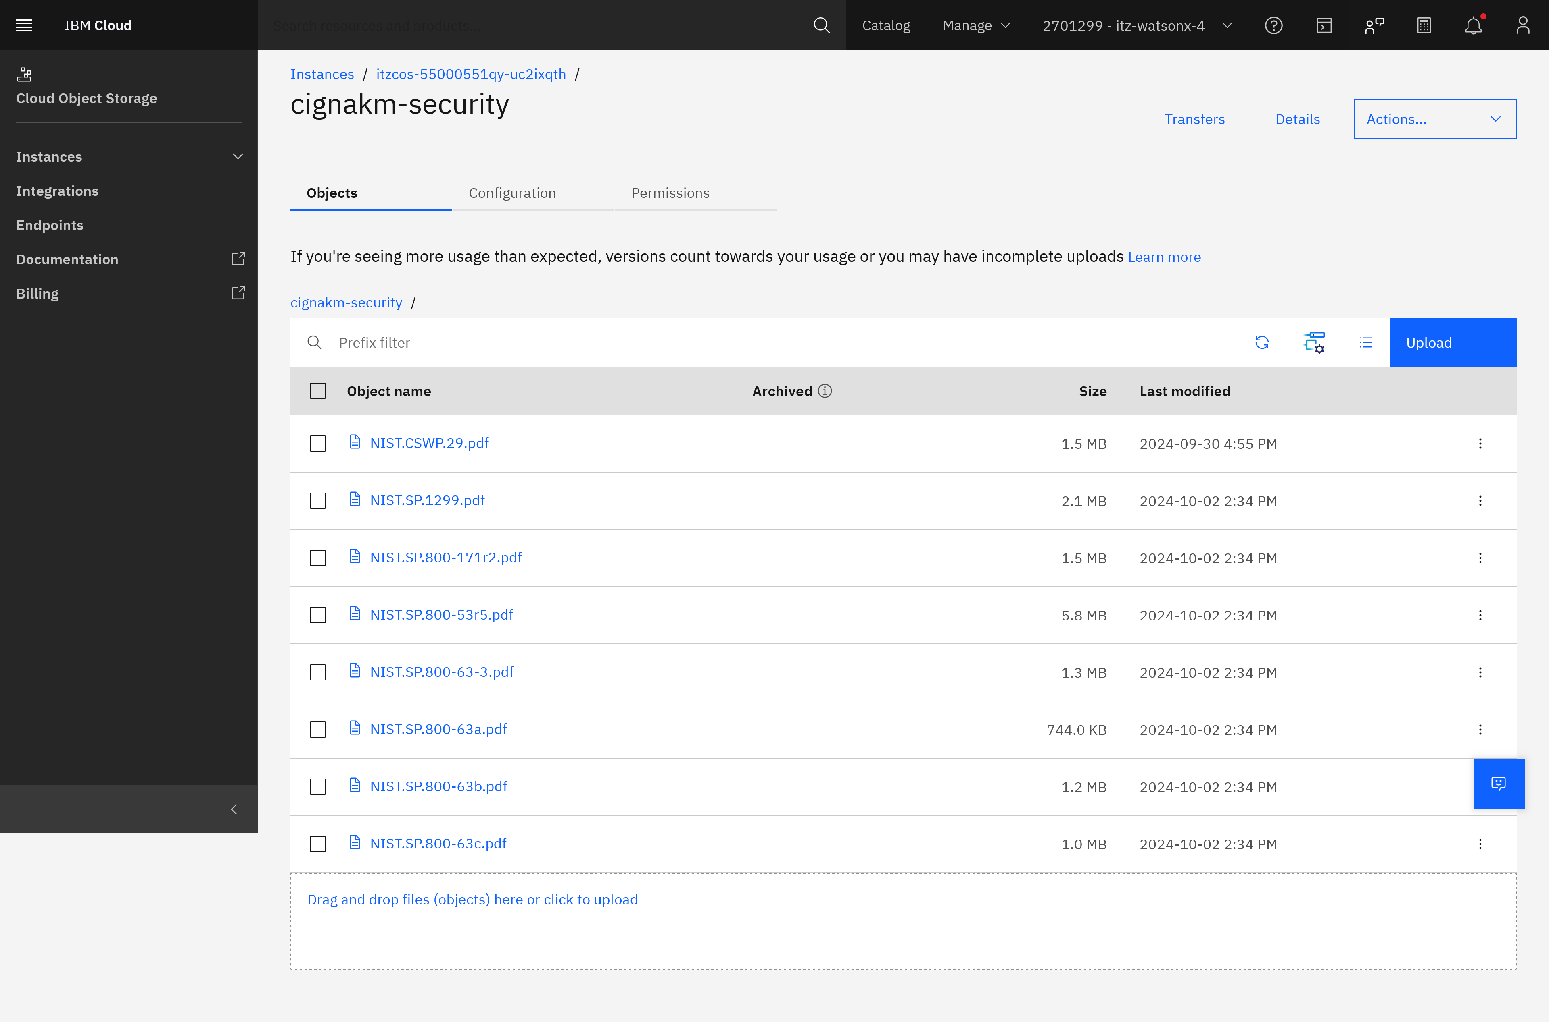

1. To view the contents of the individual document, click the object name. Then click download object.

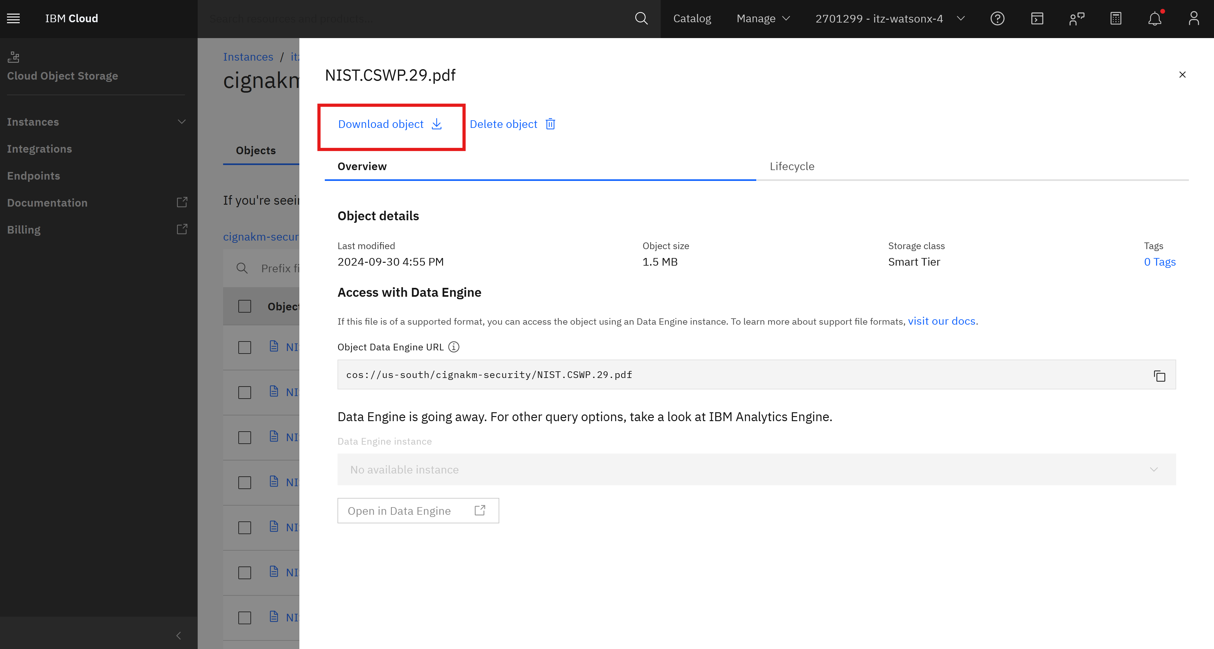

#### Upload documents to repository

1. Follow instructions 1-2 for *View documents in repository*
2. Access the **cignakm-security** Cloud Object Storage bucket [here](https://cloud.ibm.com/objectstorage/crn%3Av1%3Abluemix%3Apublic%3Acloud-object-storage%3Aglobal%3Aa%2F7dafd2ae87234398aec154c03719e731%3A126b0287-3b8f-4c81-b9d9-0e5355c0bd8f%3A%3A?bucket=cignakm-security&bucketRegion=us-south&endpoint=s3.us-south.cloud-object-storage.appdomain.cloud&paneId=bucket_overview). Click on the blue **Upload** button to open the upload menu.

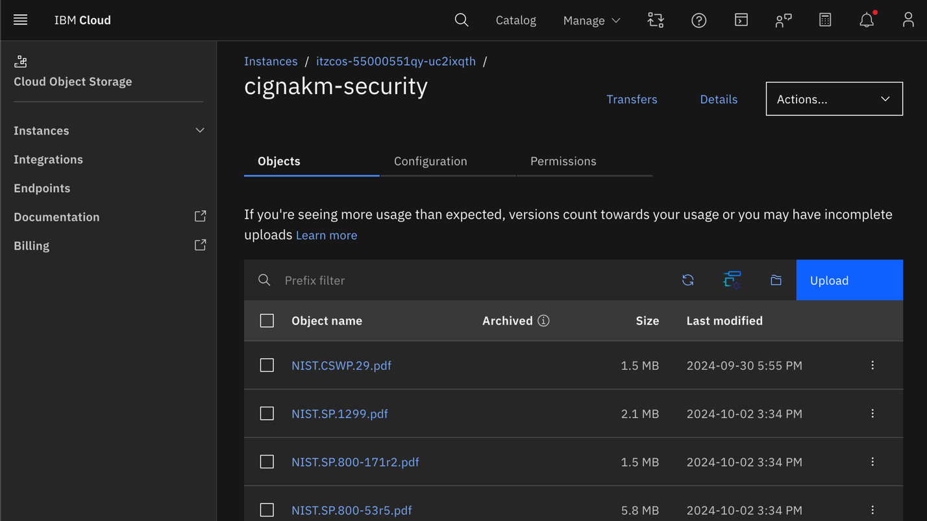

1. Under **Upload files (objects),** either drag and drop files/folders or choose one of the two **Upload…** options to browse local file storage and select a file/folder.

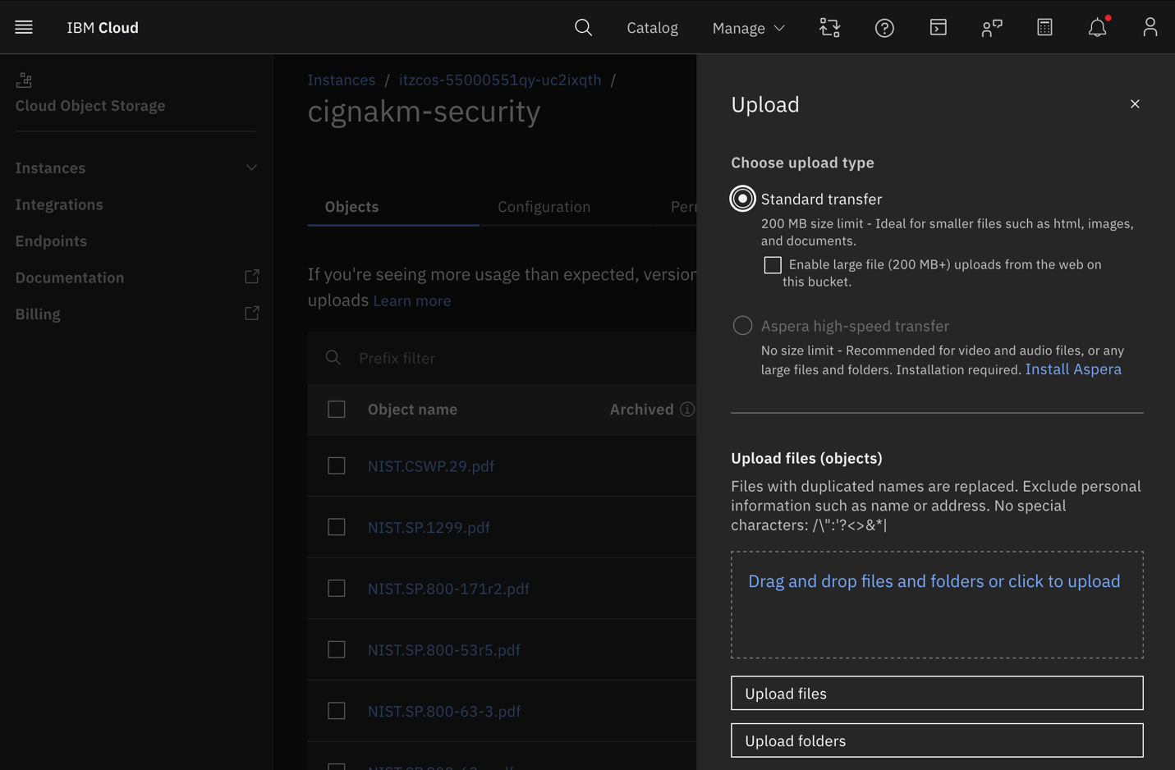

**In our pilot preview environment, we recommend uploading PDFs or DOCs. Other file types (e.g. CSV, XLS) can also be added to the repository, but optimization of those file types will be a production step.**

1. Upload the selected files/folders to the repository by clicking on the blue **Upload** button.

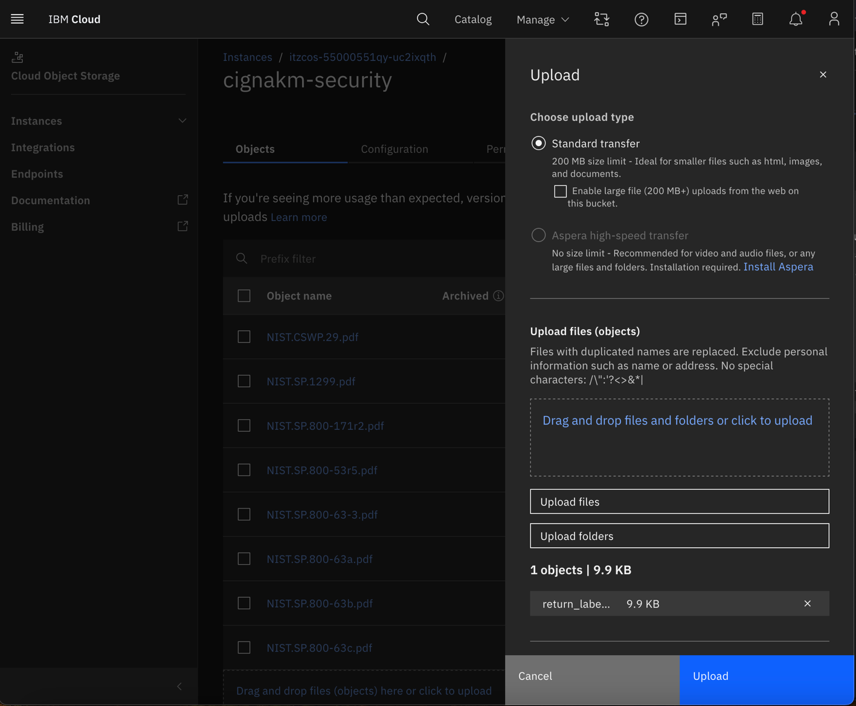

**To avoid latency in the pilot preview environment, we recommend uploading no more than 1 GB of uploads.**

#### Ask questions of repository using cognitive assistant (watsonx assistant)

1. From the cloud object storage bucket main page ([cignakm-security](https://cloud.ibm.com/objectstorage/crn%3Av1%3Abluemix%3Apublic%3Acloud-object-storage%3Aglobal%3Aa%2F7dafd2ae87234398aec154c03719e731%3A126b0287-3b8f-4c81-b9d9-0e5355c0bd8f%3A%3A?bucket=cignakm-security&bucketRegion=us-south&endpoint=s3.us-south.cloud-object-storage.appdomain.cloud&paneId=bucket_overview)), click “Upload”

#### View “chunked” documents in watsonx Discovery (IBM Cloud Databases for ElasticSearch)

1. Log into [watsonx Discovery](https://itz-watson-apps-grce0fe7-kibana-app.1kozoate8e9c.us-south.codeengine.appdomain.cloud)

* **watsonx Discovery credentials**
  + **username:** ibm_cloud_5f84d356_300f_4e2d_b68f_4f278a476b85
  + **password:** c10bb068c0b6b25e3ef04c795096398c7a99c26f5d1374158ff73a6f4973730c

1. Navigate to the index containing indexed documents from the IBM cloud object storage repository (named: *search-cigna-uploads*): Direct link to [*search-cigna-uploads*](https://itz-watson-apps-grce0fe7-kibana-app.1kozoate8e9c.us-south.codeengine.appdomain.cloud/app/enterprise_search/content/search_indices/search-cigna-uploads)
   * To view document chunks, from [*search-cigna-uploads*](https://itz-watson-apps-grce0fe7-kibana-app.1kozoate8e9c.us-south.codeengine.appdomain.cloud/app/enterprise_search/content/search_indices/search-cigna-uploads):
     + Click “Documents” tab

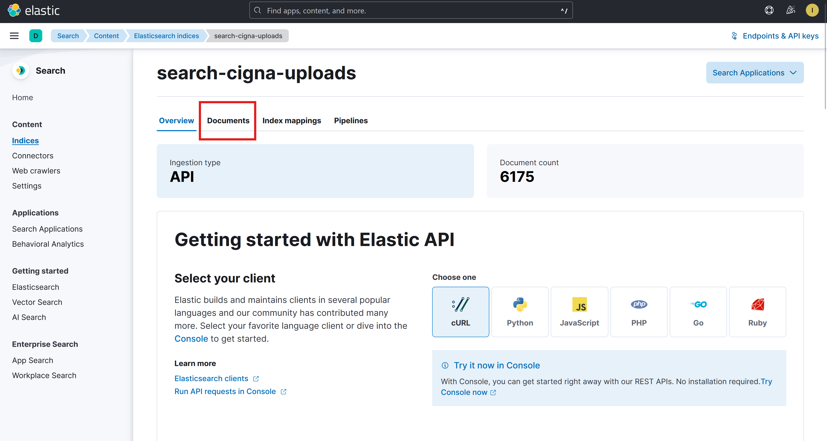

* + - Search for the document name using the top search bar or manually scrolling

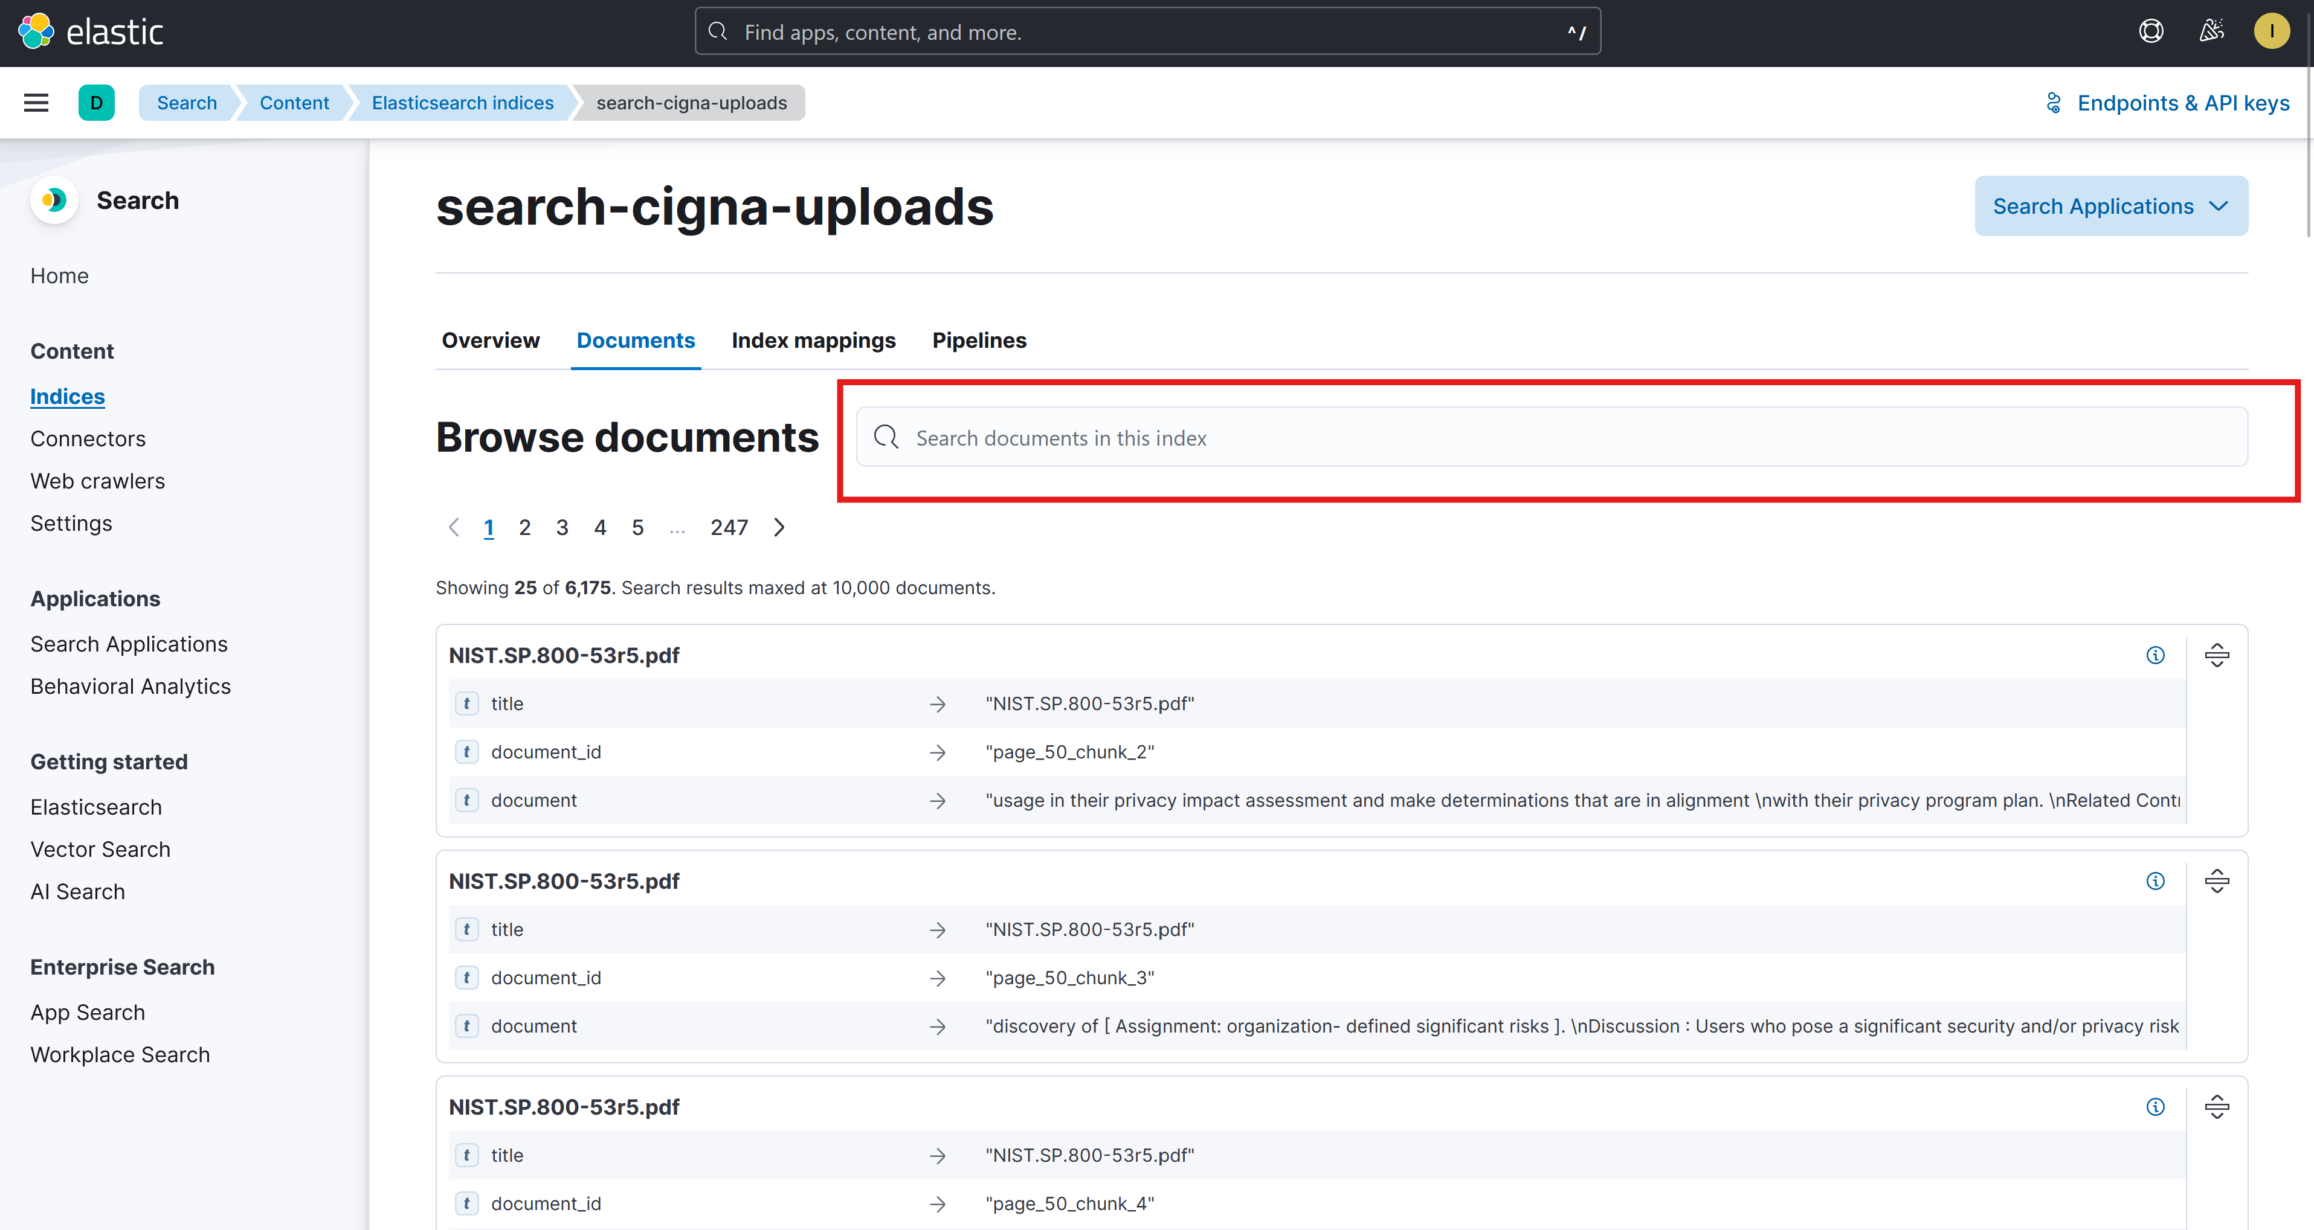

* + - To expand document, click the right expand button:

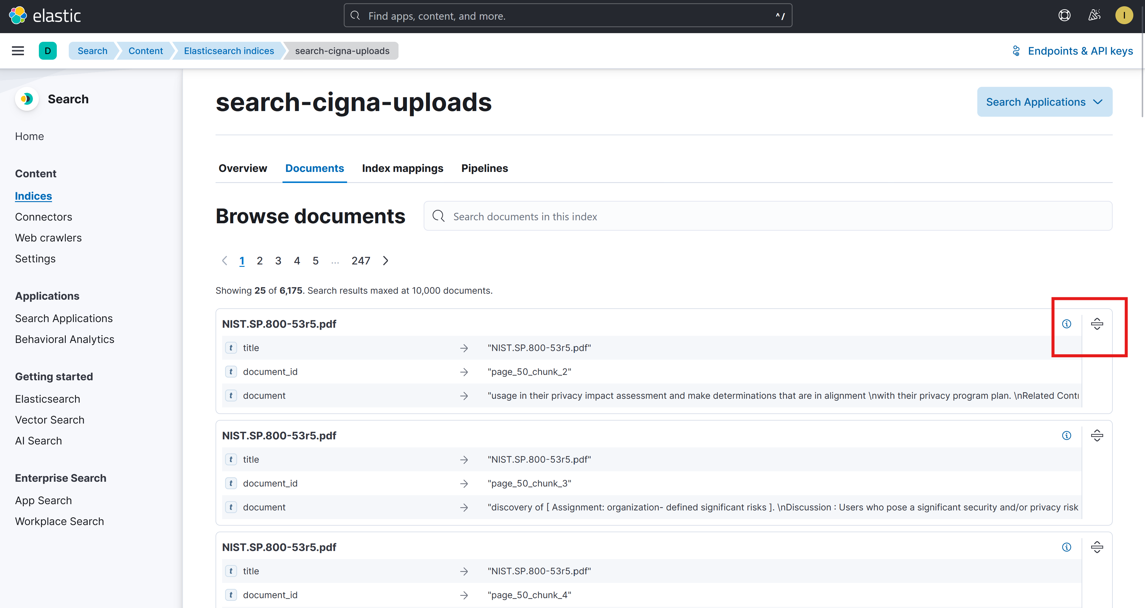

#### Use watsonx assistant to ask questions against knowledge base

* 1. Access the Demo Uploads watsonx Assistant preview link [here](https://web-chat.global.assistant.watson.appdomain.cloud/preview.html?backgroundImageURL=https%3A%2F%2Fus-south.assistant.watson.cloud.ibm.com%2Fpublic%2Fimages%2Fupx-84024428-95e3-4425-b490-db7a60d07a13%3A%3Ae3727816-6f95-4f55-8444-03d68ad0c83e&integrationID=cd9b0552-6cfe-4106-baec-f96e068d3ce5&region=us-south&serviceInstanceID=84024428-95e3-4425-b490-db7a60d07a13) and interact with the chat to ask a question, ask a new question, and end the conversation.

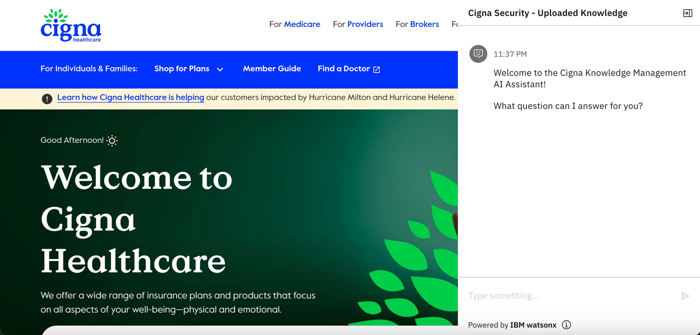

### Interaction 2: User asks questions of webpages indexed via web crawl

#### View webpages indexed in watsonx Discovery (IBM Cloud Databases for ElasticSearch)

1. Log into [watsonx Discovery](https://itz-watson-apps-grce0fe7-kibana-app.1kozoate8e9c.us-south.codeengine.appdomain.cloud)

* **watsonx Discovery credentials**
  + **username:** ibm_cloud_5f84d356_300f_4e2d_b68f_4f278a476b85
  + **password:** c10bb068c0b6b25e3ef04c795096398c7a99c26f5d1374158ff73a6f4973730c

1. Navigate to the index containing indexed documents from the web crawl process (named: [*search-cigna-crawl*](https://itz-watson-apps-grce0fe7-kibana-app.1kozoate8e9c.us-south.codeengine.appdomain.cloud/app/enterprise_search/content/search_indices/search-cigna-crawl)).
   * To view document chunks, from [*search-cigna-crawl*](https://itz-watson-apps-grce0fe7-kibana-app.1kozoate8e9c.us-south.codeengine.appdomain.cloud/app/enterprise_search/content/search_indices/search-cigna-crawl):
     + Click “Documents” tab

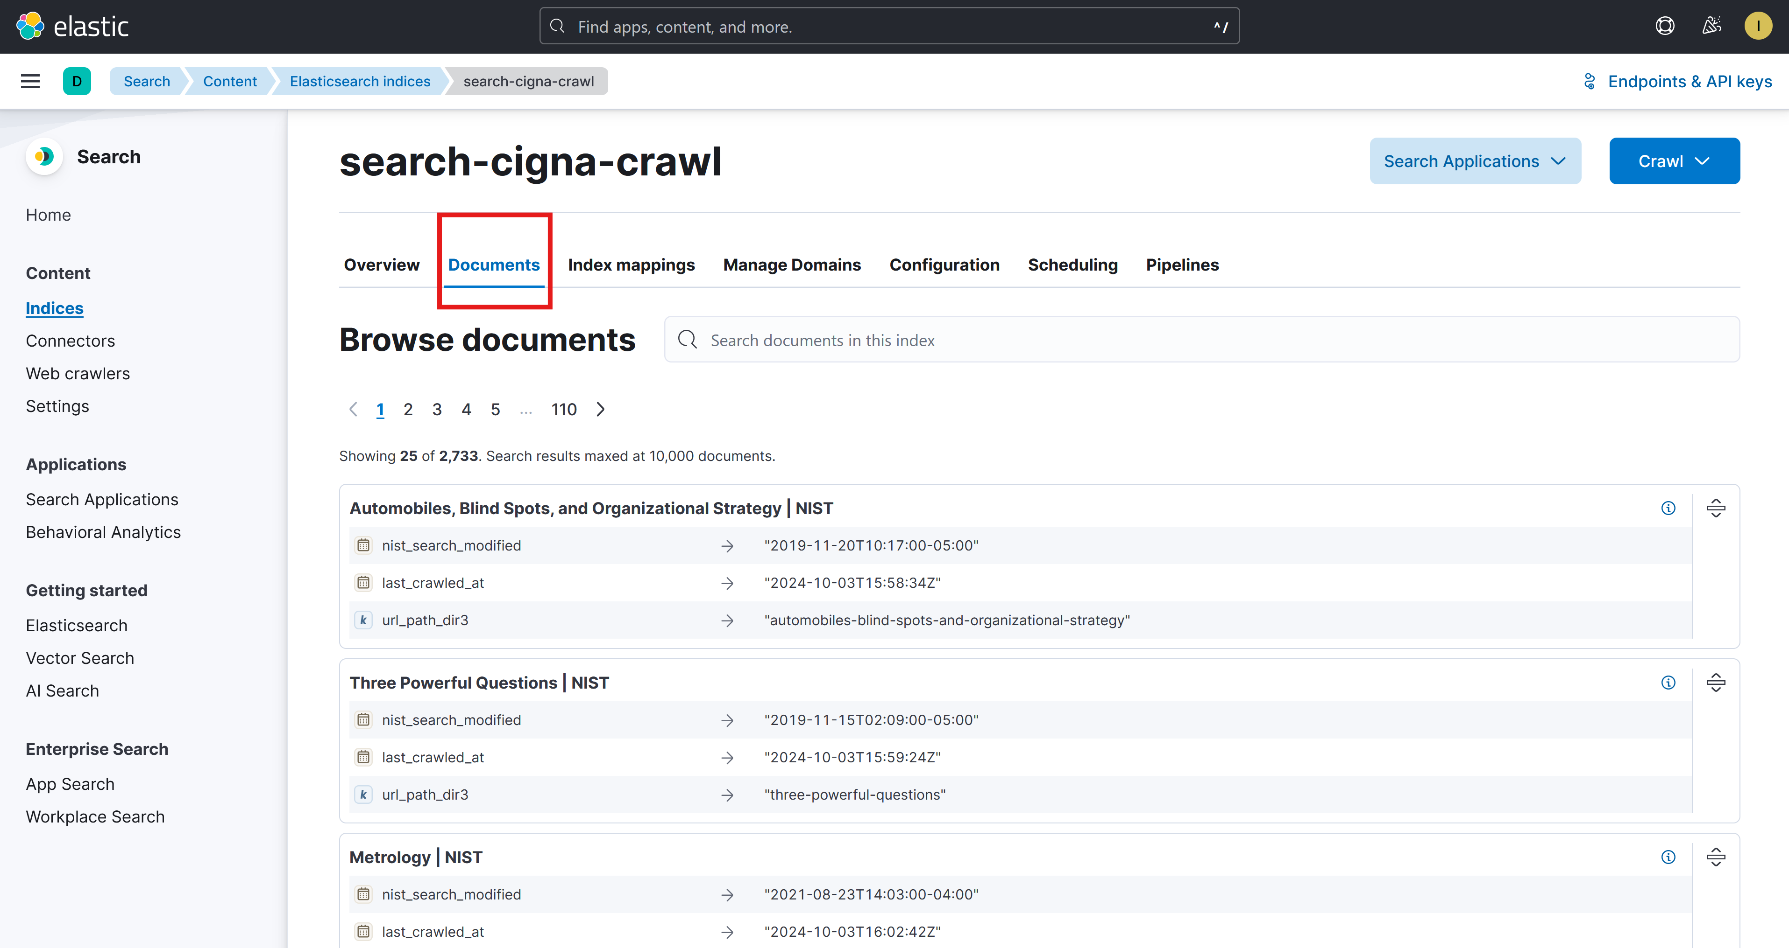

* + - Search for the document name using the top search bar or manually scrolling

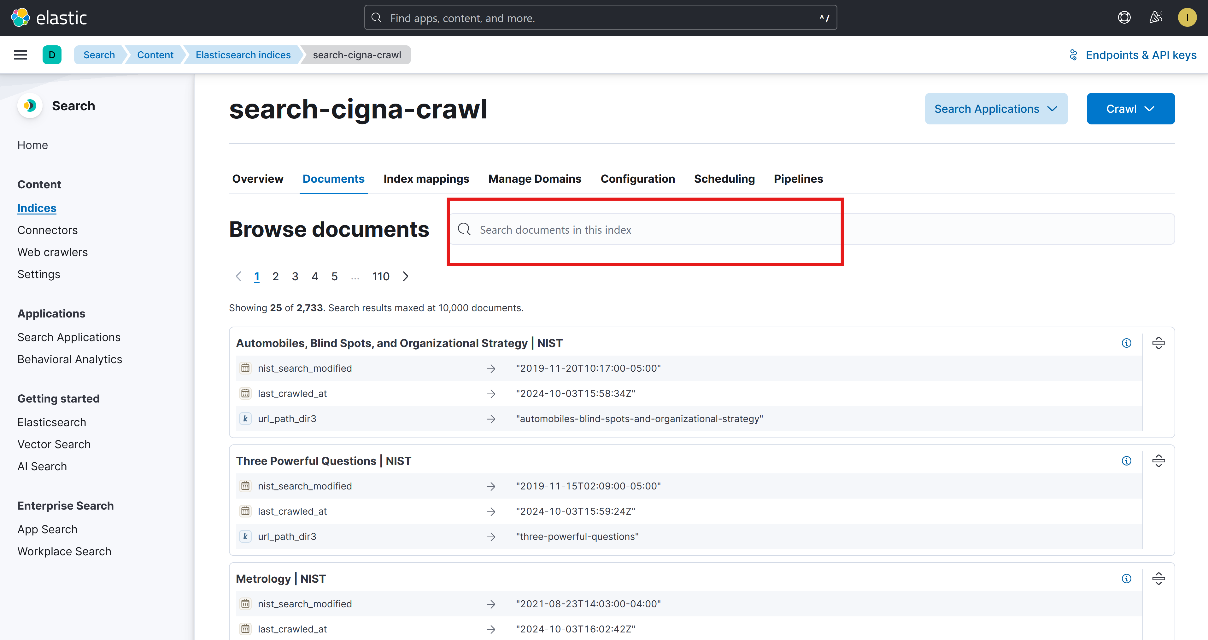

* + - To expand document, click the right expand button:

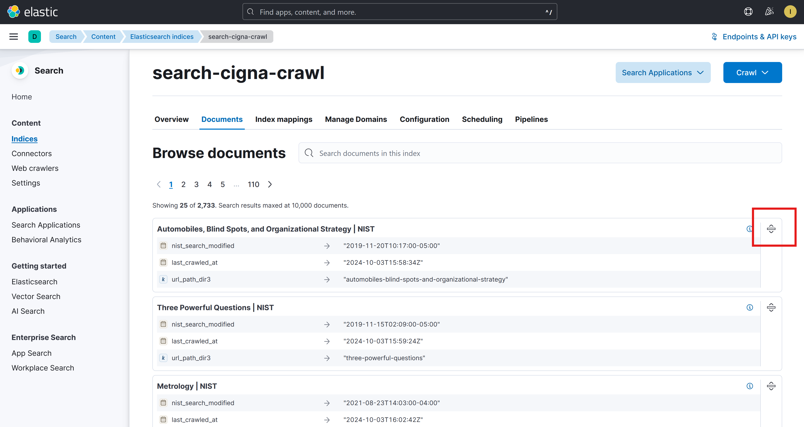

#### Crawl new webpages

**Important Usage Note: The preview environment is configured to add specific webpages vs crawling over a website domain. Please follow these instructions carefully as incorrect setup may inadvertently crawl and index many webpages, resulting in over-capacitating storage and causing the environment to become unstable.**

1. From the [*search-cigna-crawl*](https://itz-watson-apps-grce0fe7-kibana-app.1kozoate8e9c.us-south.codeengine.appdomain.cloud/app/enterprise_search/content/search_indices/search-cigna-crawl) *index*, click **Manage Domains.**

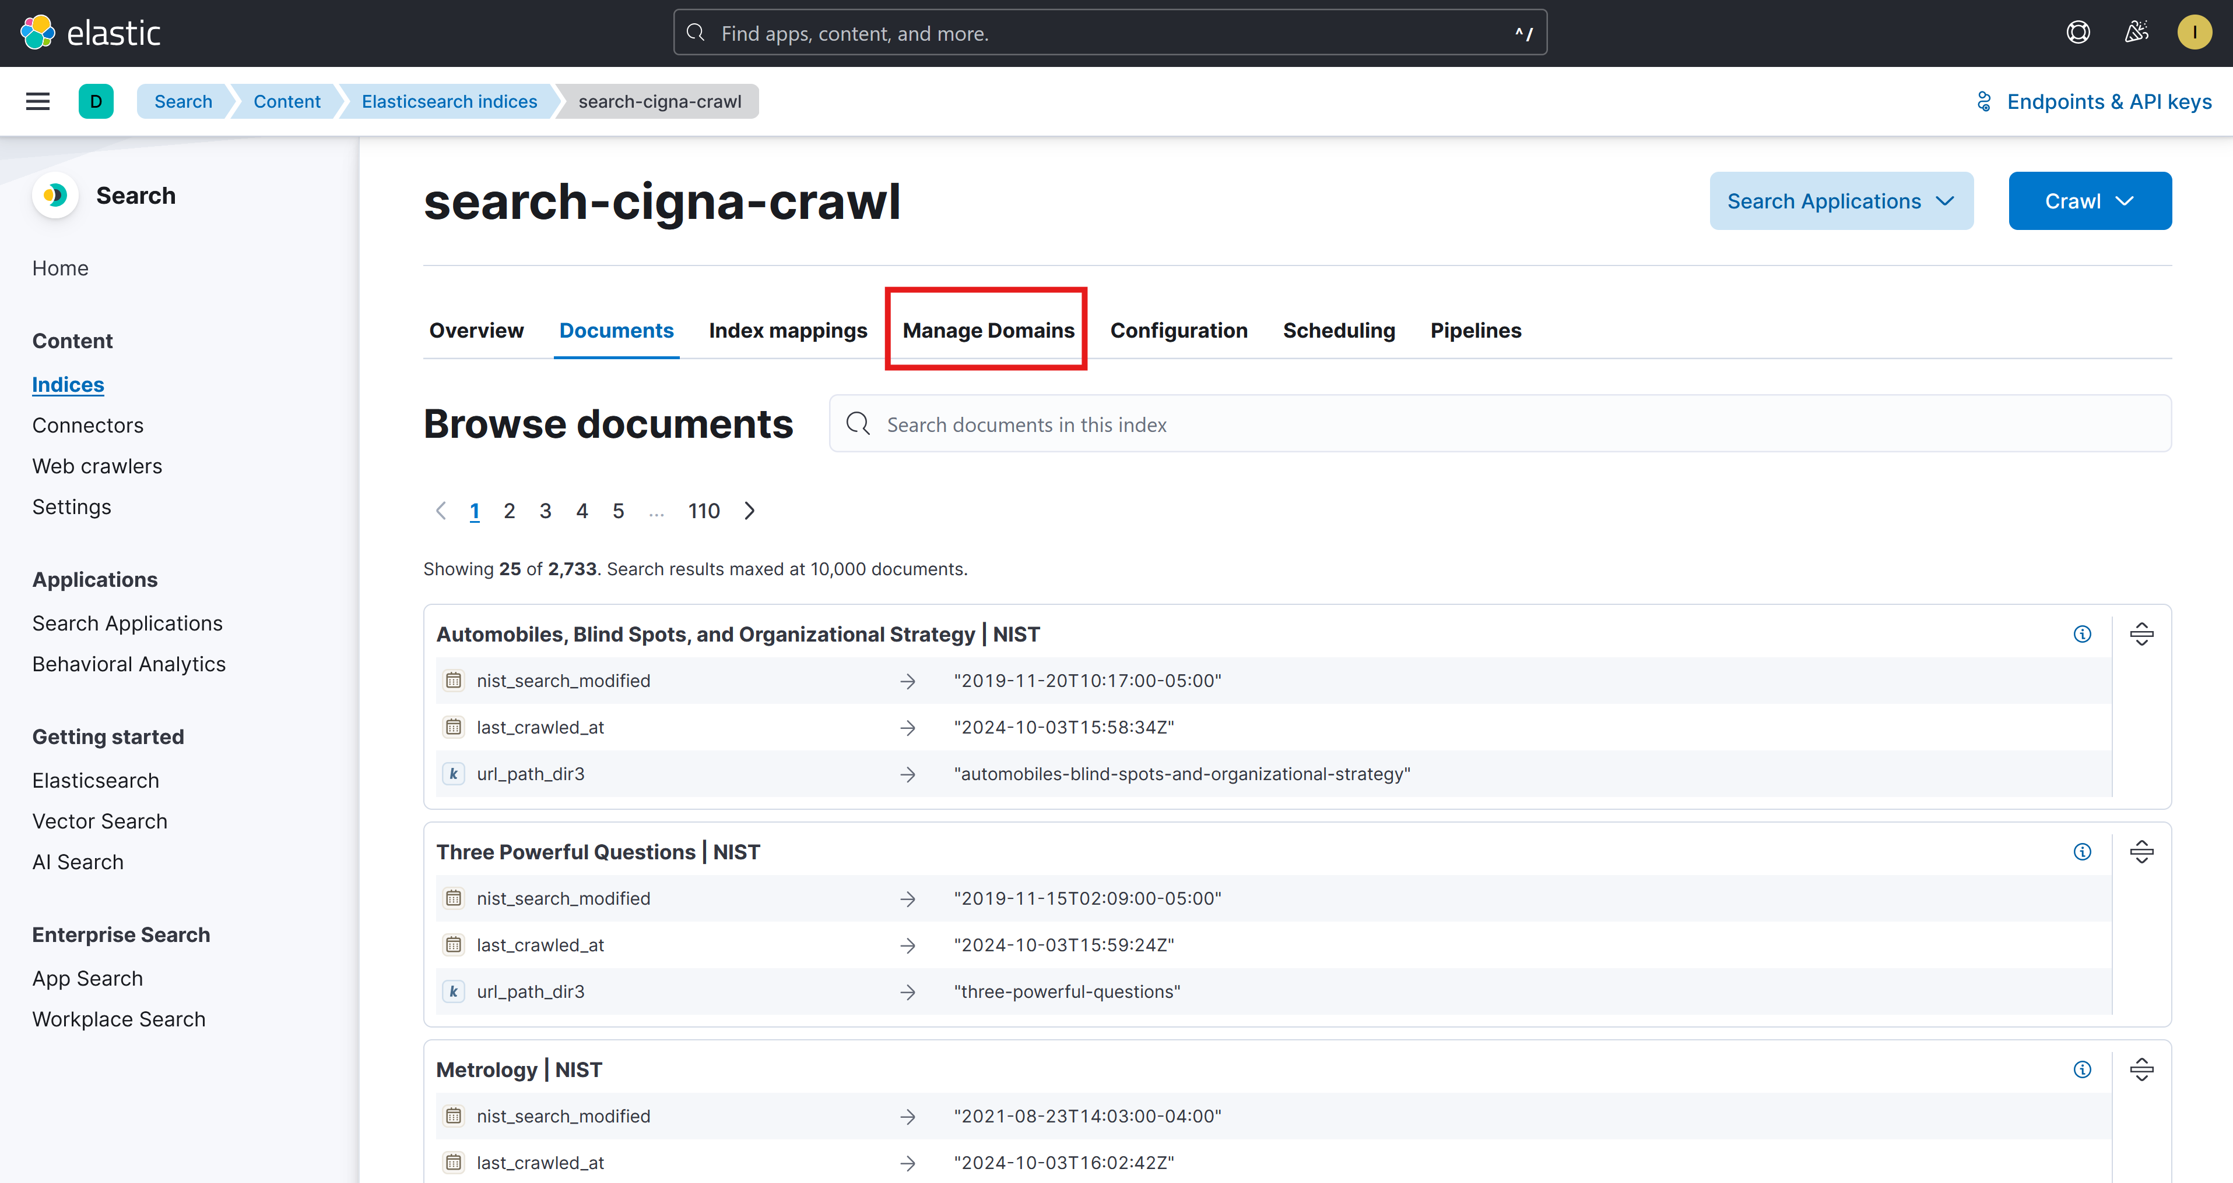

1. Decide whether the webpage you want to add has a web domain already listed. If it is listed, follow step 3. If not listed, follow step 4.

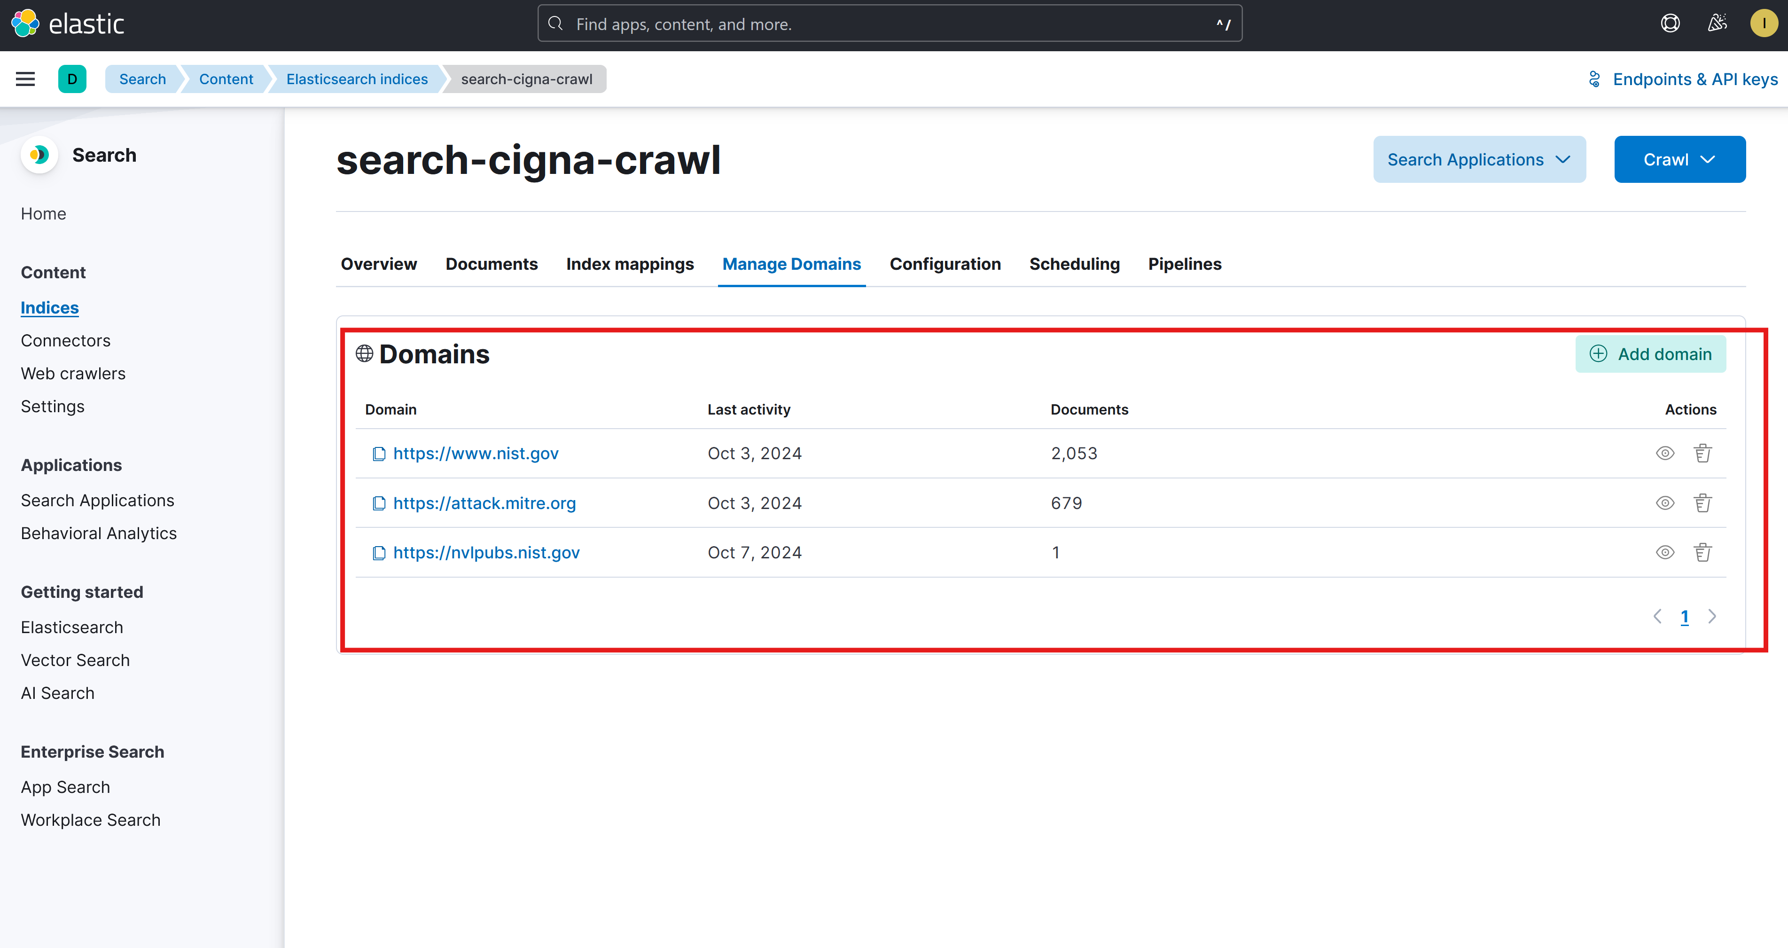

1. [Use this step if webpage you want to add **has** the same domain as one already listed as described in step 2]
   1. Click **Add Domain**

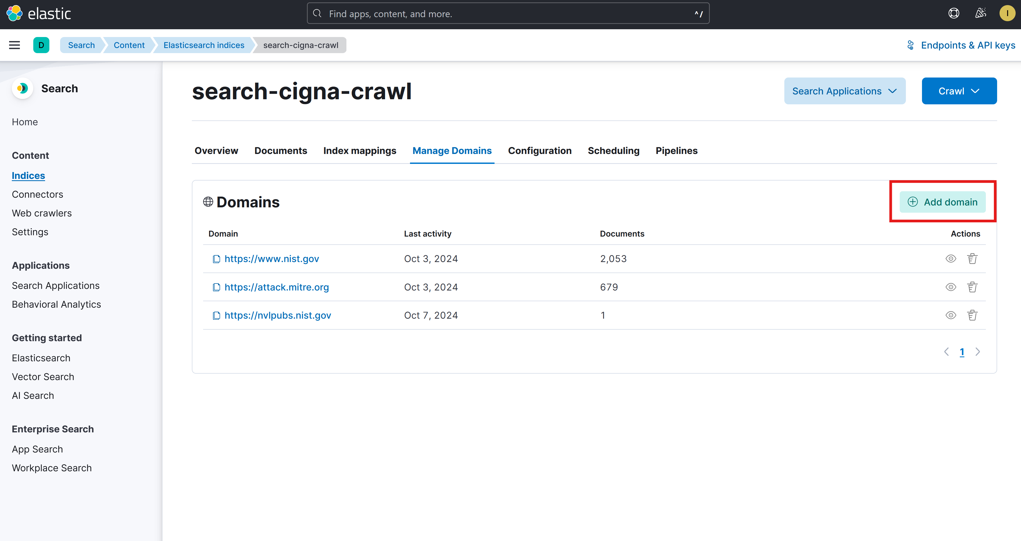

* 1. Enter the domain of the webpage url that you want to add and click **Validate Domain**. (Example: you want to crawl the webpage <https://nvlpubs.nist.gov/nistpubs/SpecialPublications/NIST.SP.800-207.pdf> . Domain URL you would enter at this step = <https://nvlpubs.nist.gov/>)

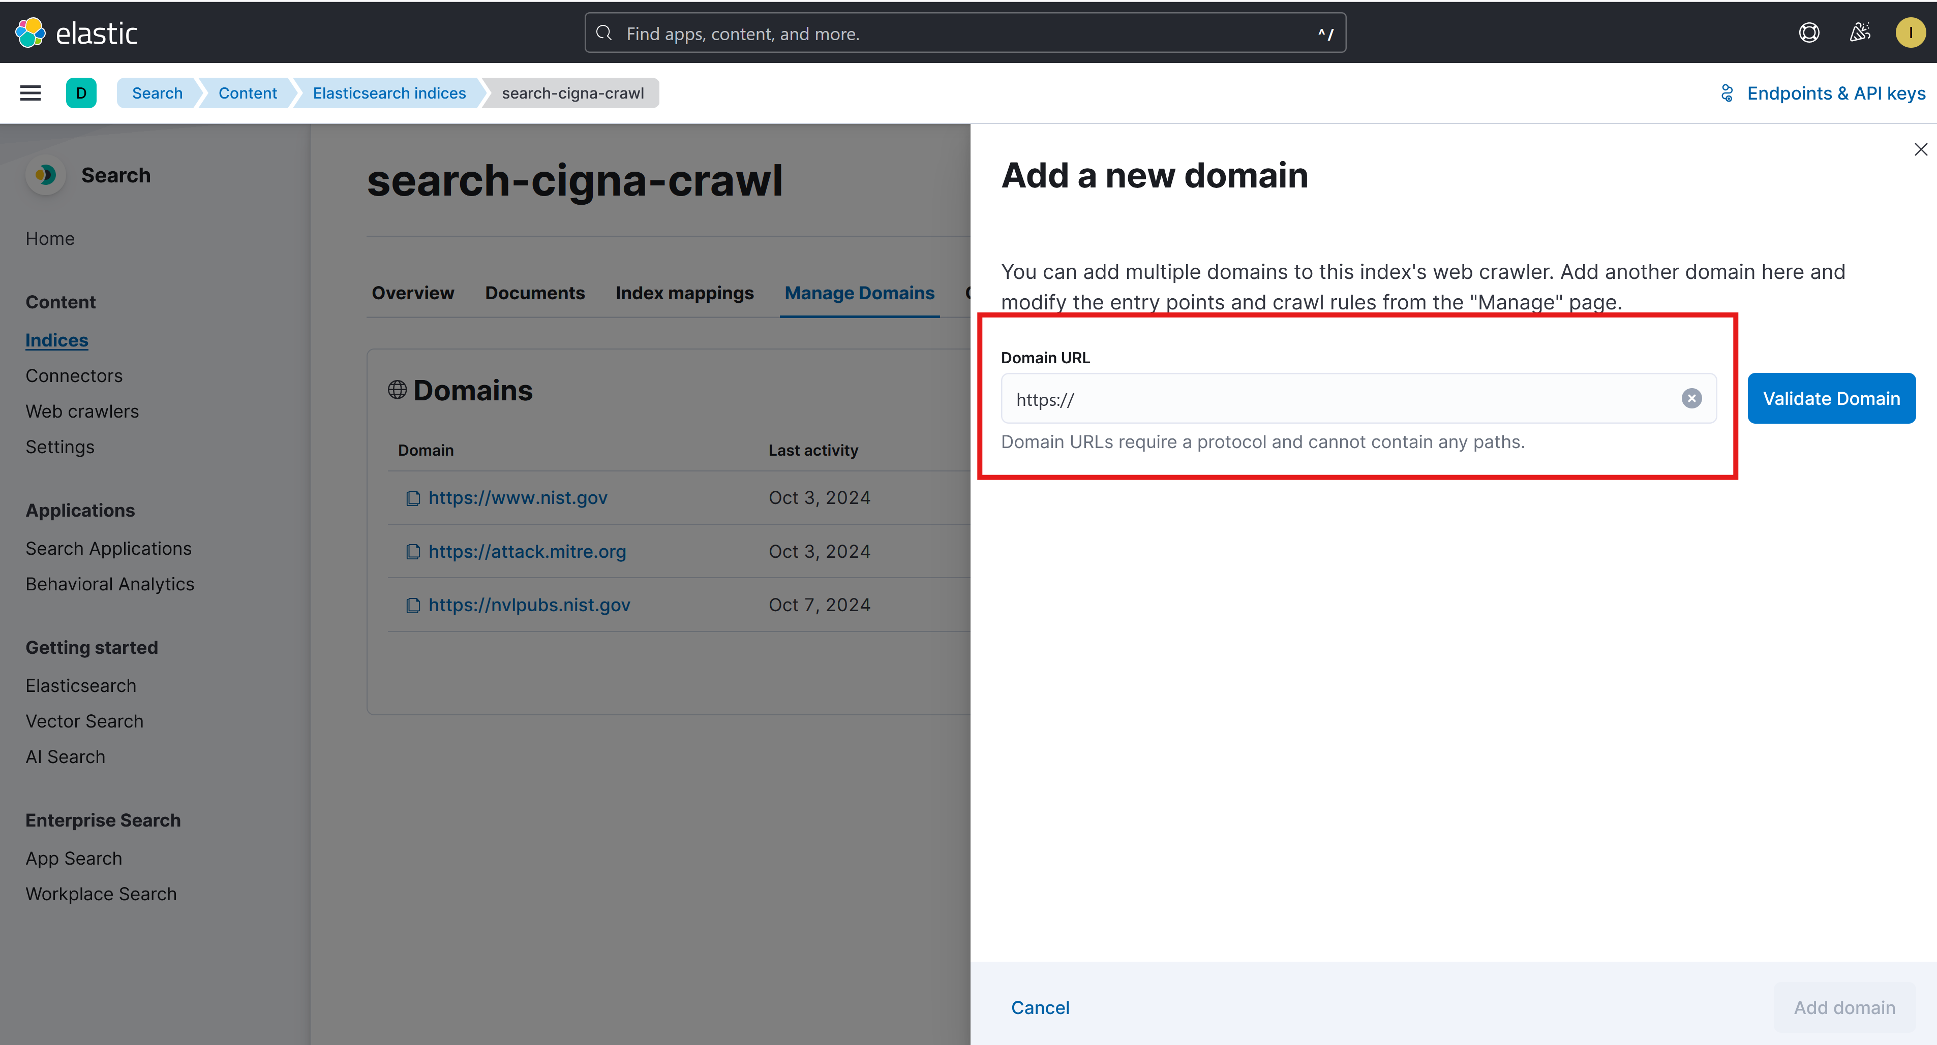

* 1. Click **Add Entry Point**

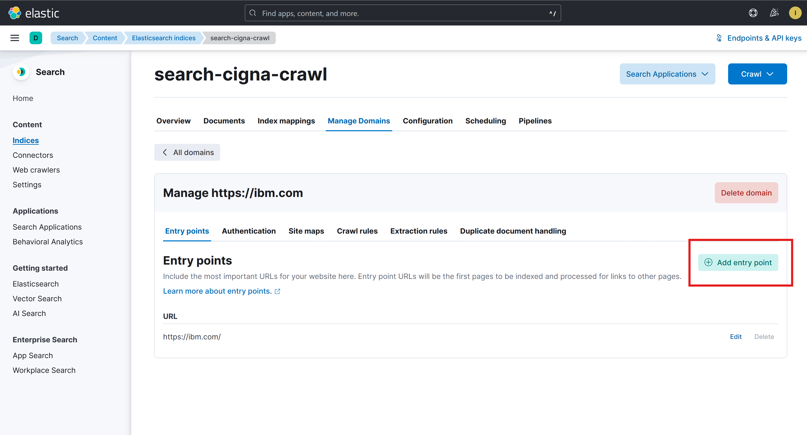

* 1. Enter the suffix of the webpage (all of the URL following the domain url), and click **Save.**

Example:

* + - Full URL: <https://www.ibm.com/docs/en/db2/11.5?topic=fundamentals-performance-tuning>
    - Domain URL: <https://www.ibm.com>
    - Entry point: /docs/en/db2/11.5?topic=fundamentals-performance-tuning

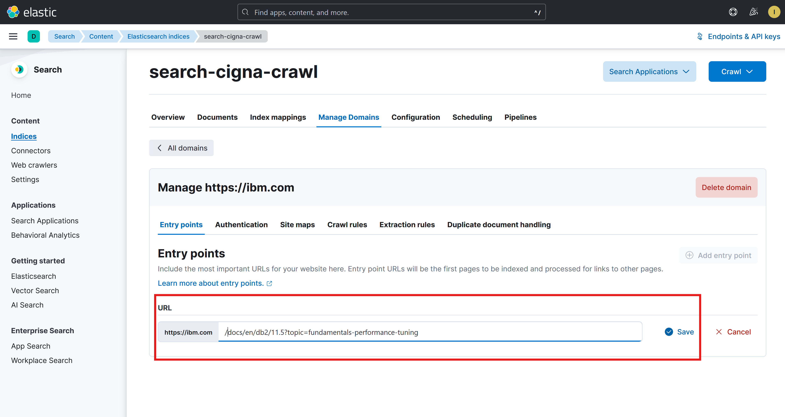

* 1. **IMPORTANT-follow carefully.** Click **Crawl**, then click **Crawl with custom settings.**

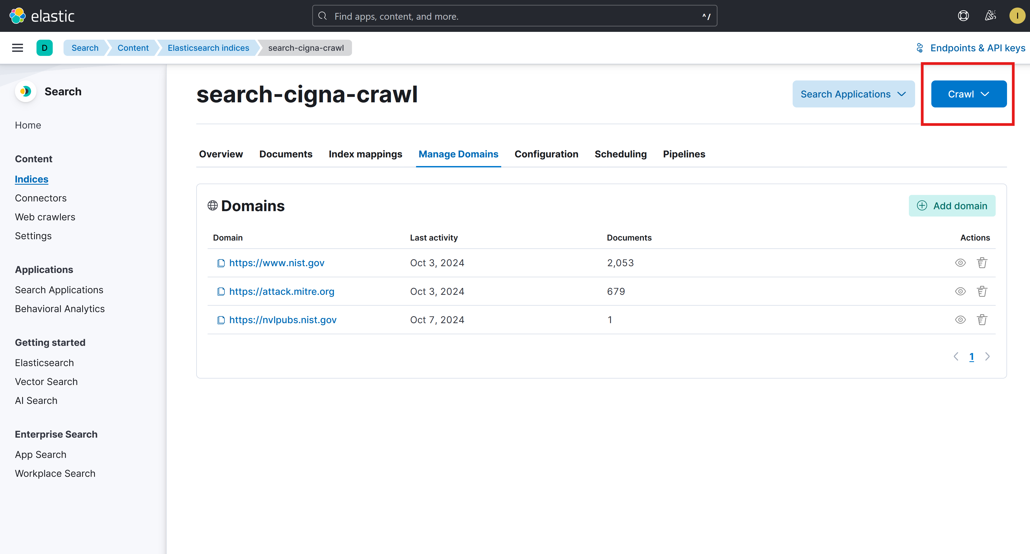

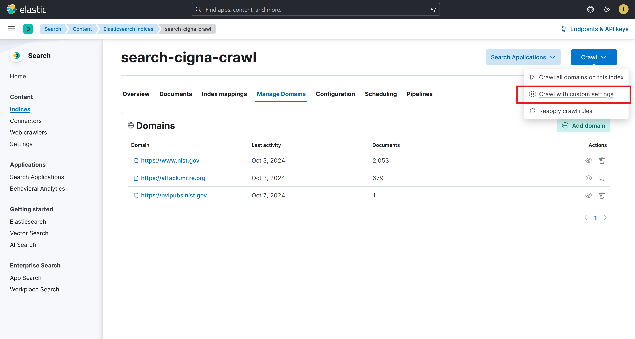

* 1. **IMPORTANT-follow carefully.** Use the following settings:
     1. Crawl type: **One-time crawl**
     2. Max crawl depth: **1**
     3. Add domains to your crawl: **select domain you added**
     4. Seed URLs: **select the Entry points tab, then select the entry point you added**

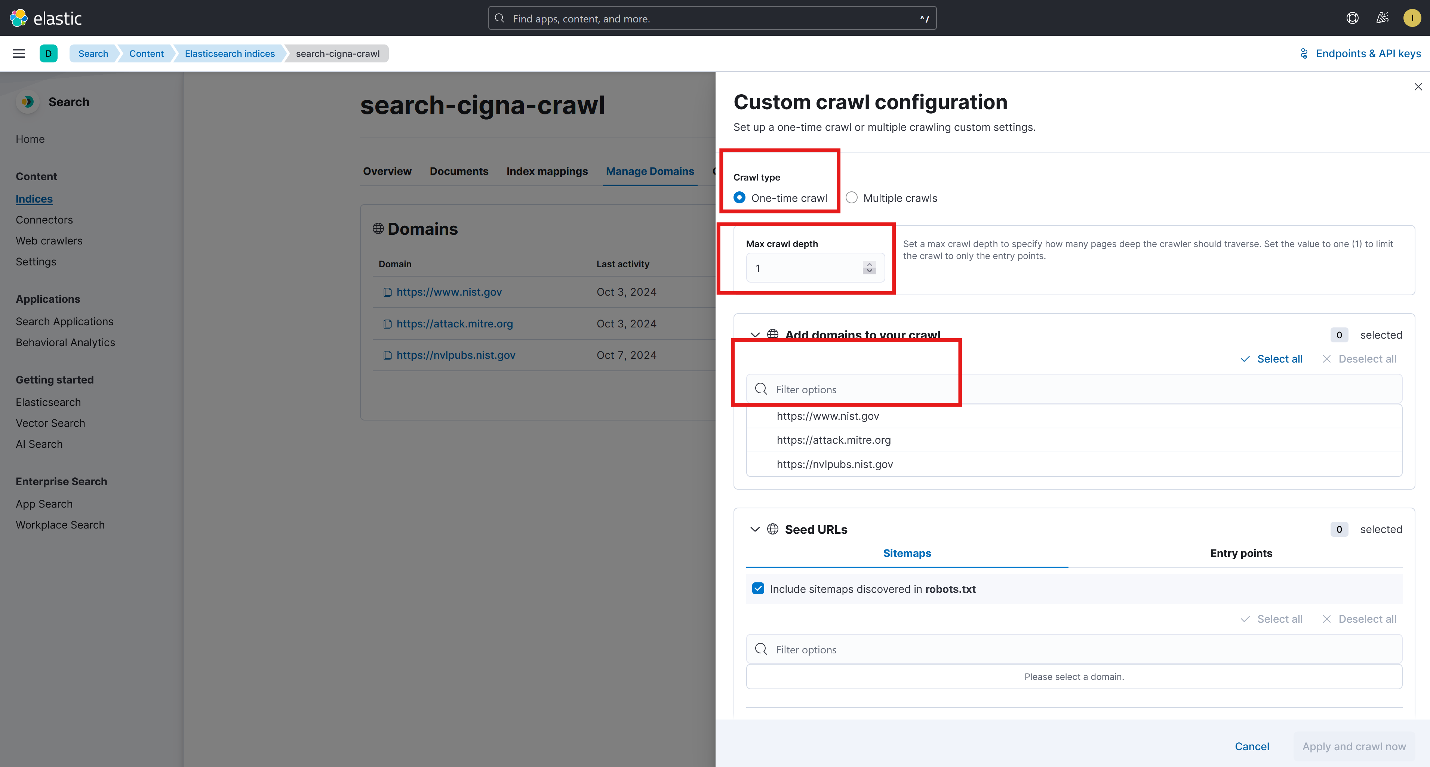

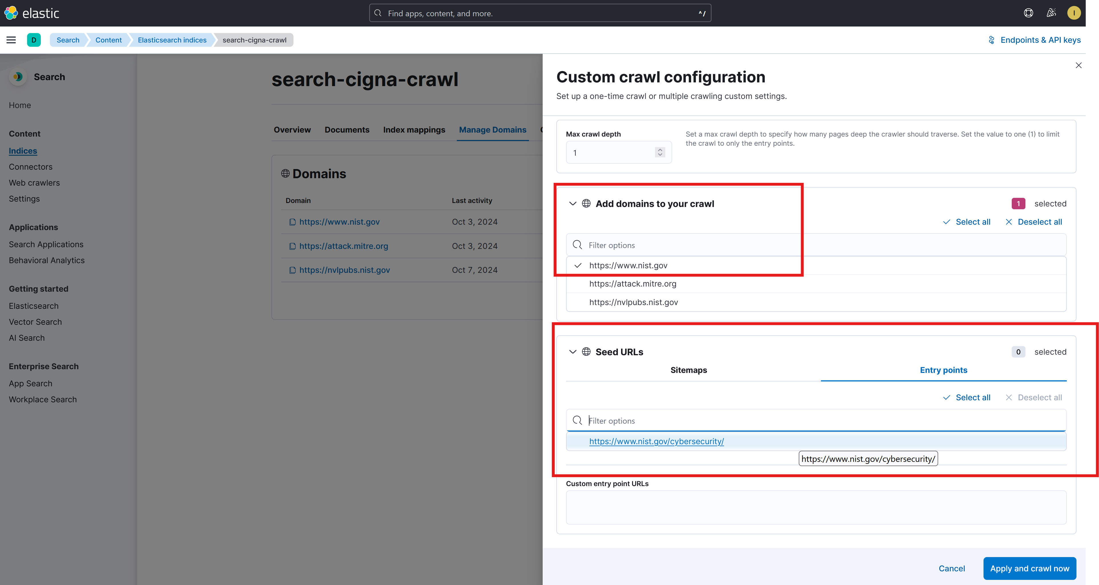

* 1. Select **Apply and crawl now**
  2. Verify completion by clicking the **Overview** tab, then looking at the **Crawl Requests** section

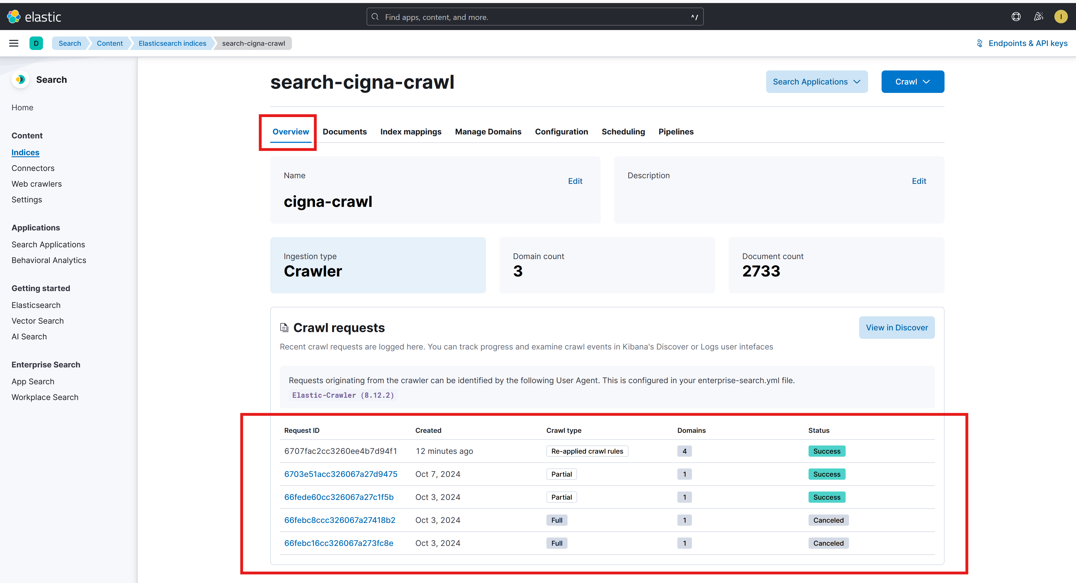

1. [Use this step if webpage you want to add **does not have** the same domain as one already listed as described in step 2]
   1. Click **Manage Domains,** then click the domain of the webpage you want to add.

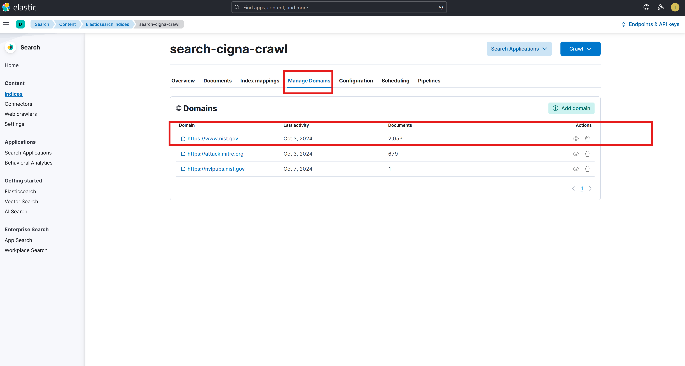

* 1. Click **Add Entry Point**



* 1. Enter the suffix of the webpage (all of the URL following the domain url) and click **Save.**

Example:

* + - Full URL: <https://www.ibm.com/docs/en/db2/11.5?topic=fundamentals-performance-tuning>
    - Domain URL: <https://www.ibm.com>
    - Entry point: /docs/en/db2/11.5?topic=fundamentals-performance-tuning



* 1. Click **Crawl rules** tab and click **Add crawl rule**.

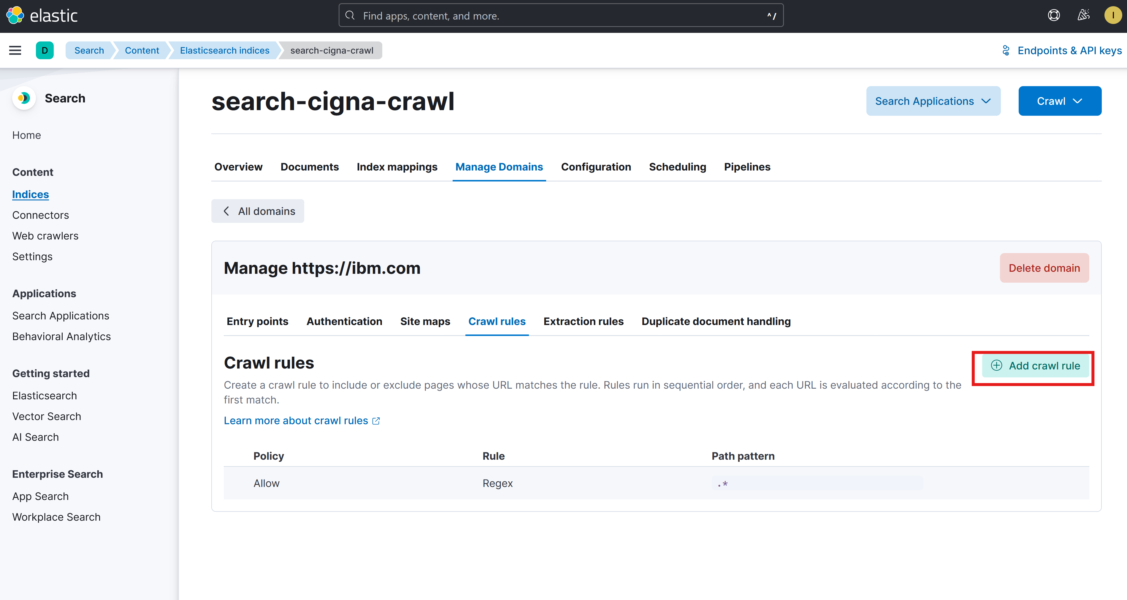

* 1. Add the following crawl rule, and click **save:**
     1. Policy**: Disallow**
     2. Rule: **Regex**
     3. Path pattern: **.\***
  2. **IMPORTANT-follow carefully.** Click **Crawl**, then click **Crawl with custom settings.**





* 1. **IMPORTANT-follow carefully.** Use the following settings:
     1. Crawl type: **One-time crawl**
     2. Max crawl depth: **1**
     3. Add domains to your crawl: **select domain you added**
     4. Seed URLs: **select the Entry points tab, then select the entry point you added**





* 1. Select **Apply and crawl now**
  2. Verify completion by clicking the **Overview** tab, then looking at the **Crawl Requests** section



#### Use watsonx assistant to ask questions against web crawl knowledge base

1. Access the Demo Uploads watsonx Assistant preview link [here](https://web-chat.global.assistant.watson.appdomain.cloud/preview.html?backgroundImageURL=https%3A%2F%2Fus-south.assistant.watson.cloud.ibm.com%2Fpublic%2Fimages%2Fupx-84024428-95e3-4425-b490-db7a60d07a13%3A%3Ad0eb190e-bf35-46ec-ab66-bb845ec45d33&integrationID=41689c01-382f-43c4-9fe5-514512dea2ee&region=us-south&serviceInstanceID=84024428-95e3-4425-b490-db7a60d07a13) and interact with the chat to ask a question, ask a new question, and end the conversation.

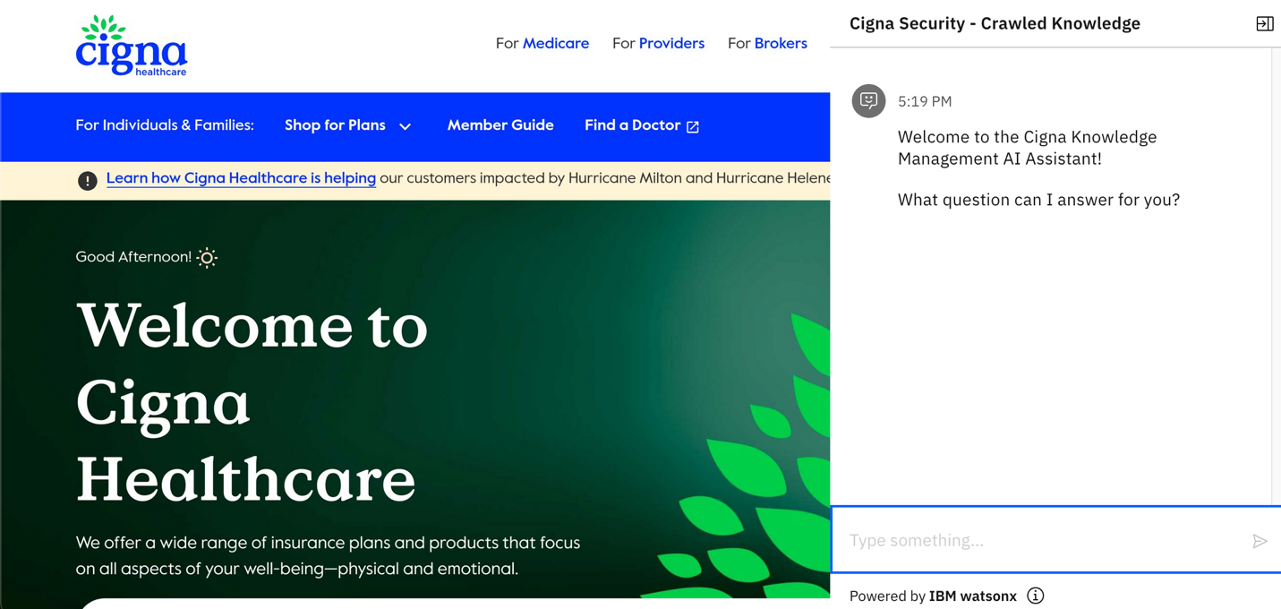

### Interaction 3: User experiments with prompt instructions in Prompt Lab

#### Use watsonx.ai Prompt Lab to experiment with prompts and LLMs

1. Access the watsonx.ai Prompt Lab for our cigna-demo-env project [here](https://dataplatform.cloud.ibm.com/wx/prompts?context=wx&project_id=49f383e6-d527-4951-a28d-9501da2435c9). Open the  upload menu.

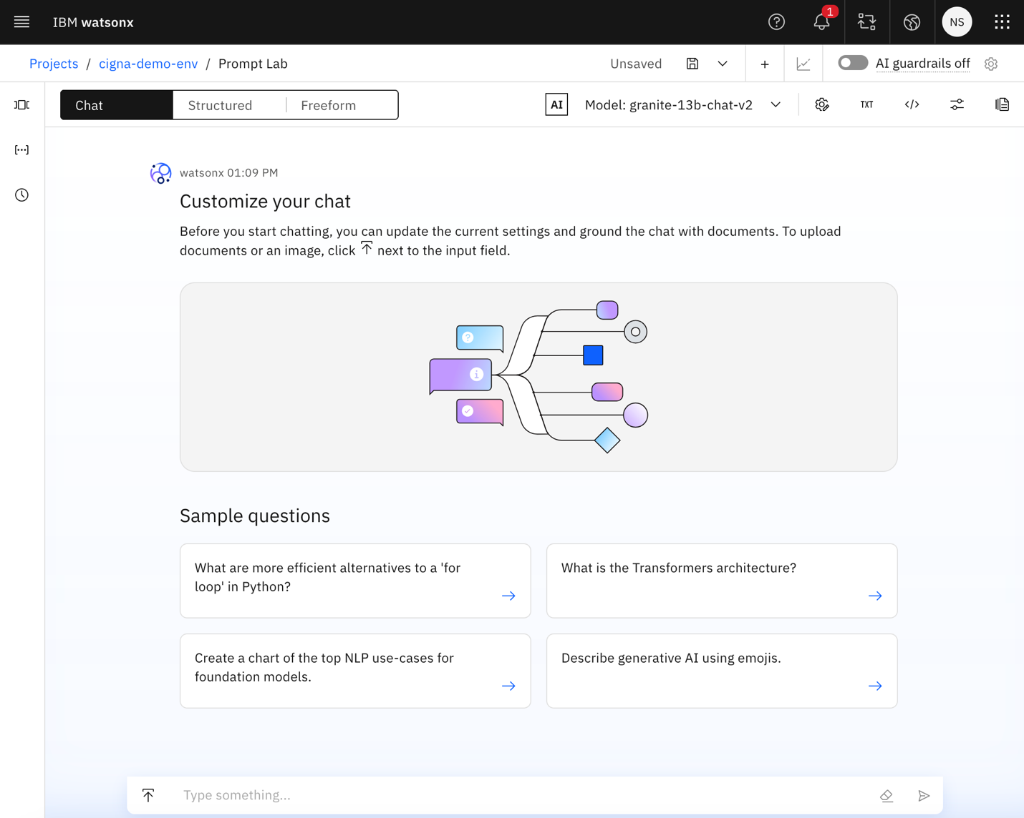

1. Click on **Add Documents.**

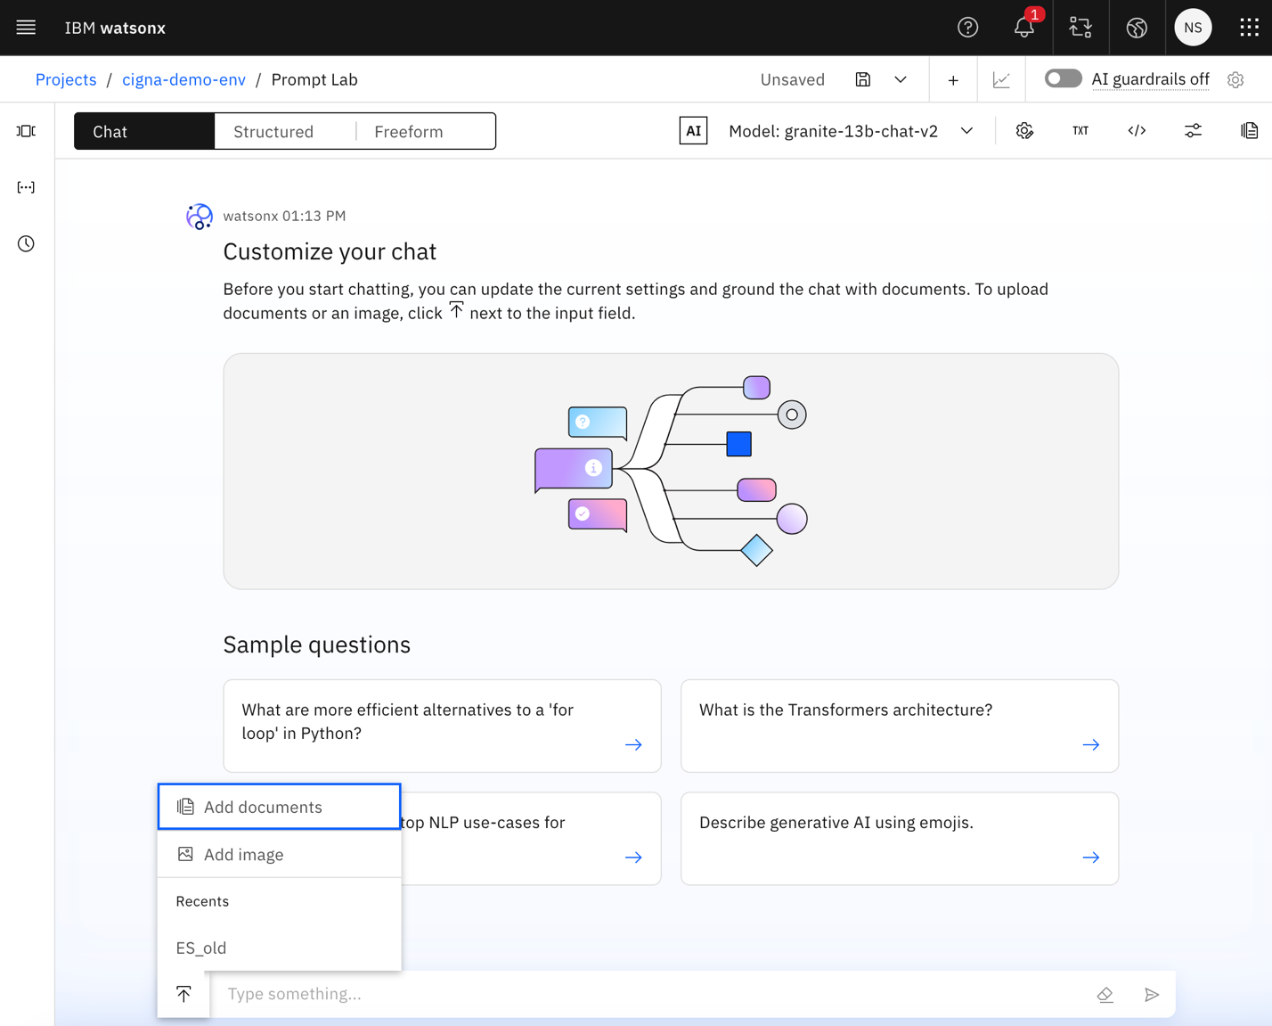

1. Add files (PPTX, DOCX, PDF, or TXT) from local storage by clicking on **Browse** and click on the blue **Create** button to save the document upload.

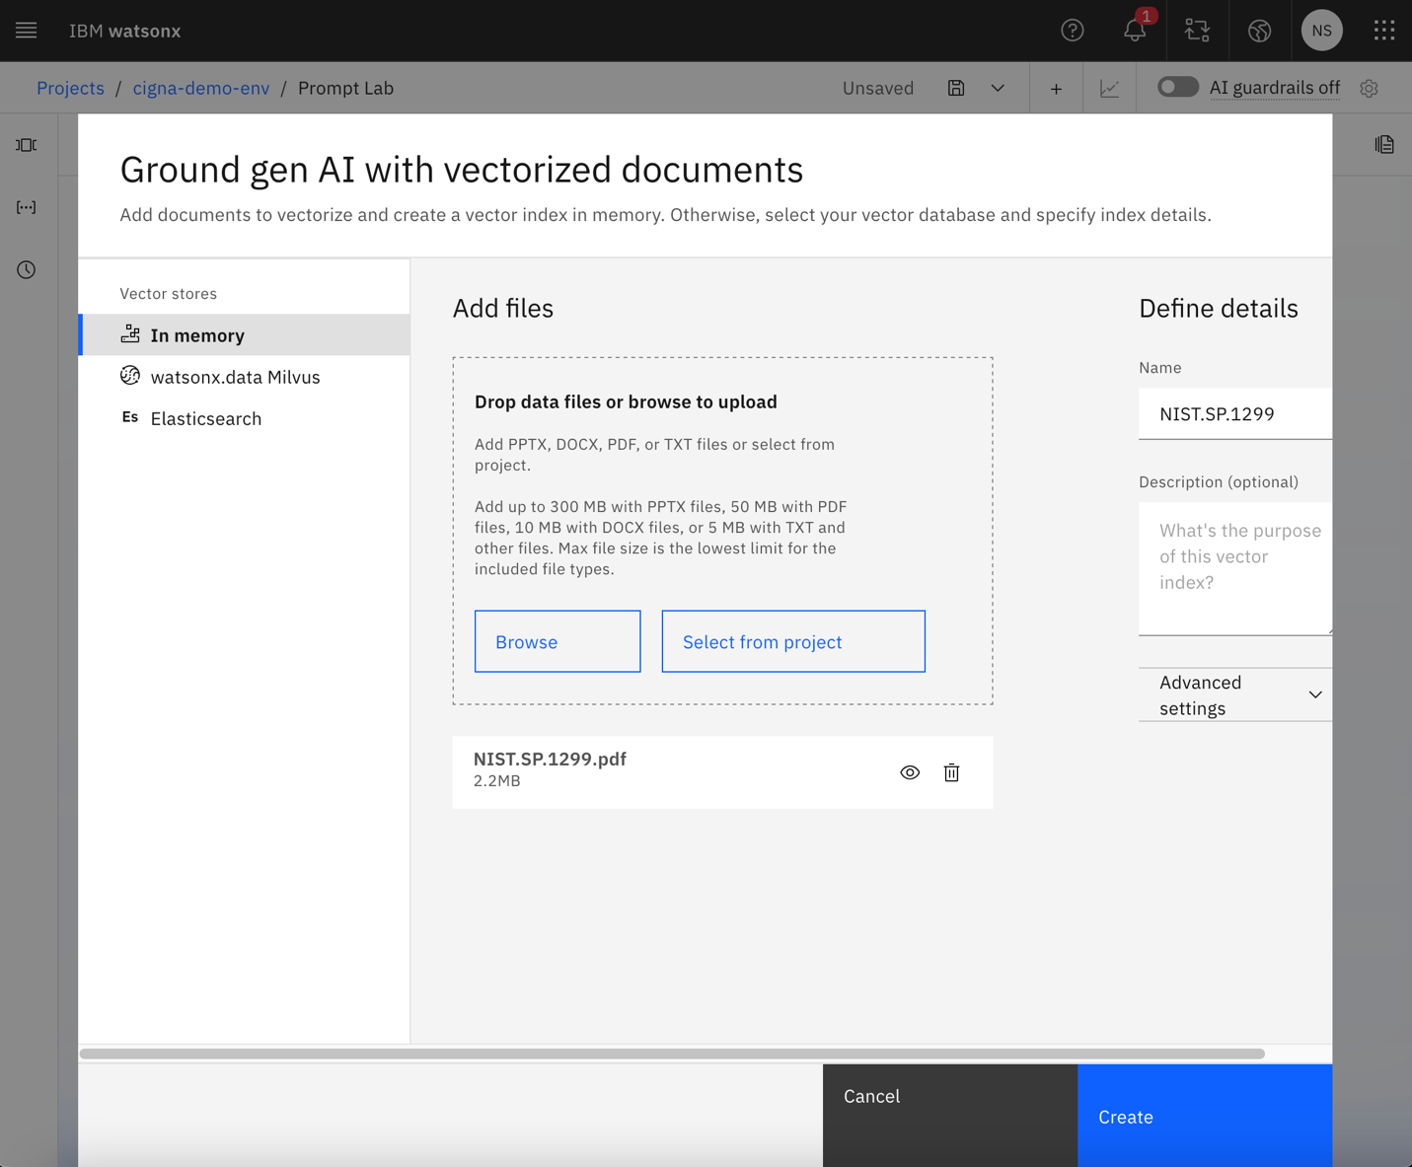

1. Note that the document is now visible above the  upload button. Click on the settings button to open the system prompt window.

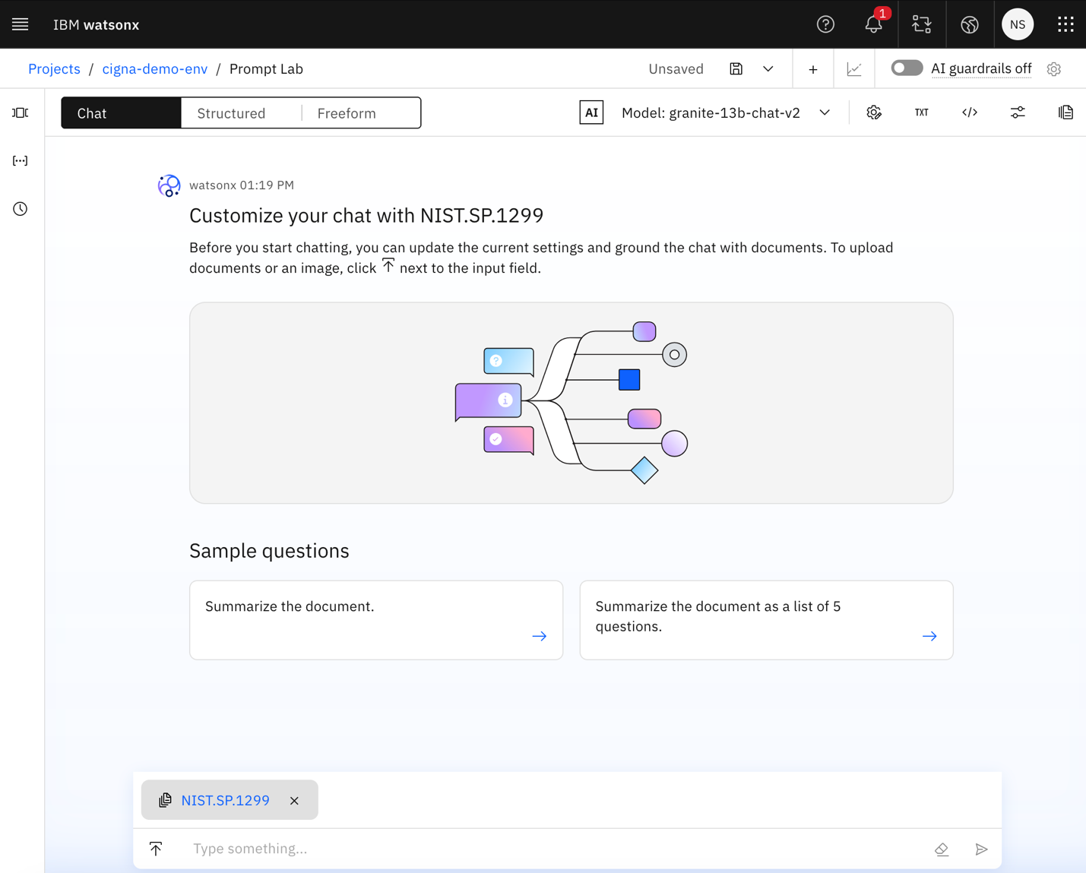

1. Make changes to the prompt instructions here and click on the blue **Save** button to save the prompt.

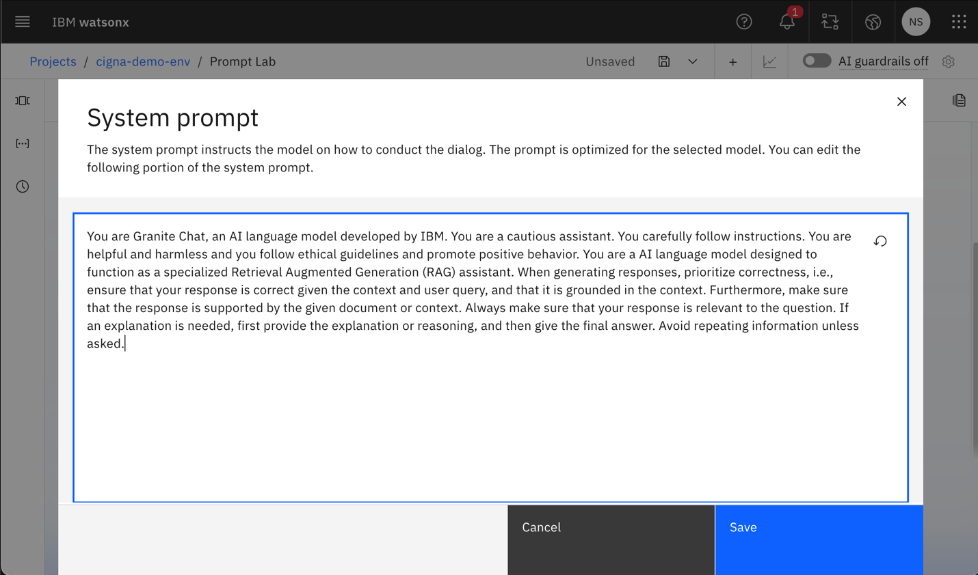

1. Ask your question of the document in the chat window

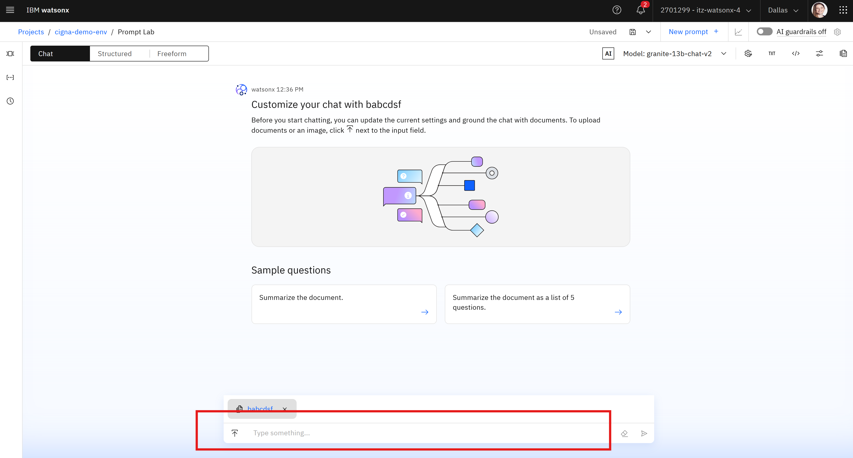

1. To change the large language model used:
   1. click the **Model:**  section in top right corner, then **View all Foundation Models:**

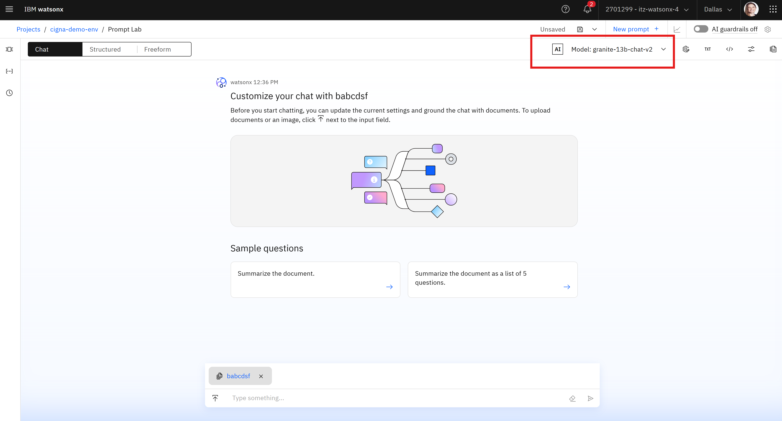

* 1. Click one of the model tiles to review details and the model factsheet.

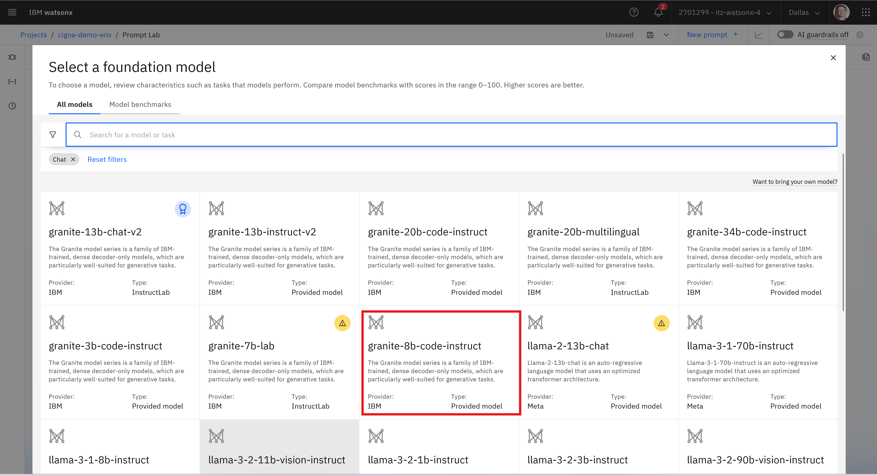

* 1. To choose the model, click the blue **Select Model** button, then click **Clear** to agree to clear chat history due to using a different LLM to ask questions.

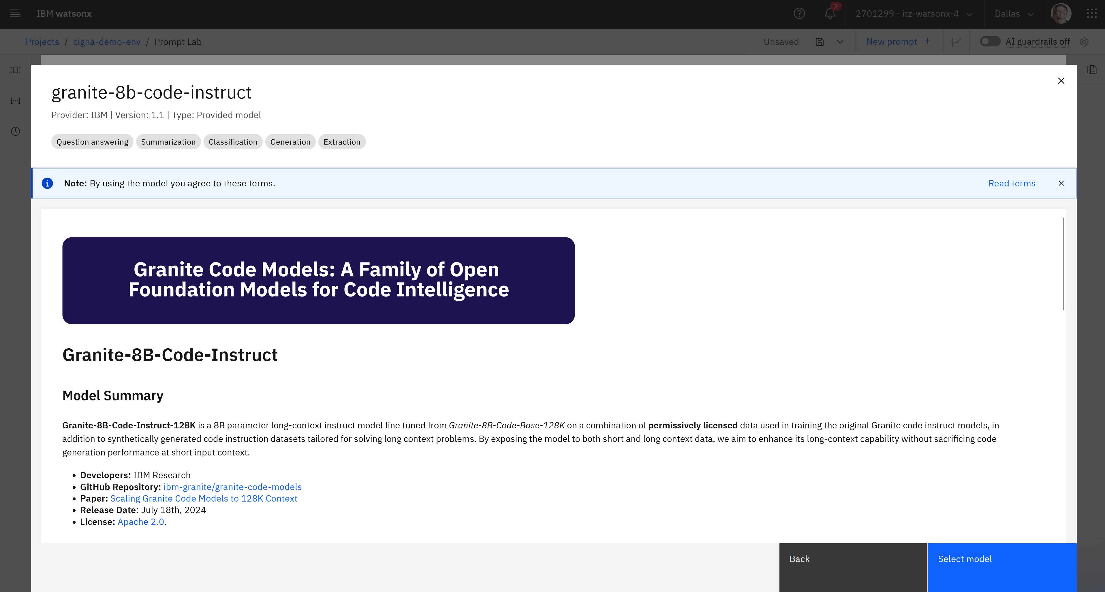

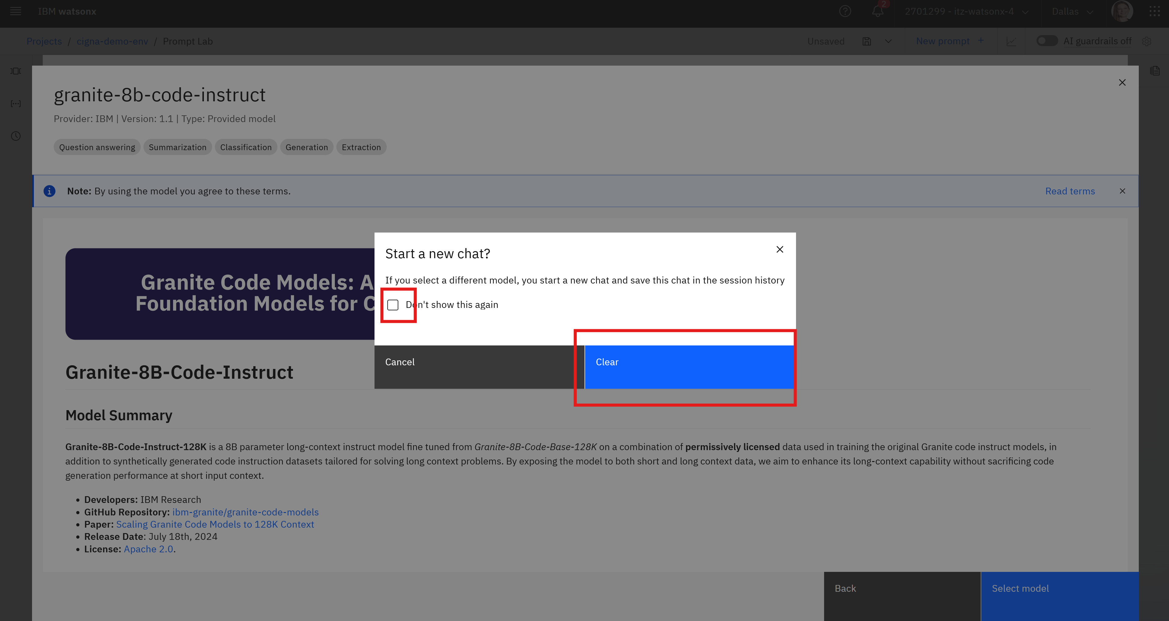

1. To save the prompt template:
   1. Click the Save button and then click Save As

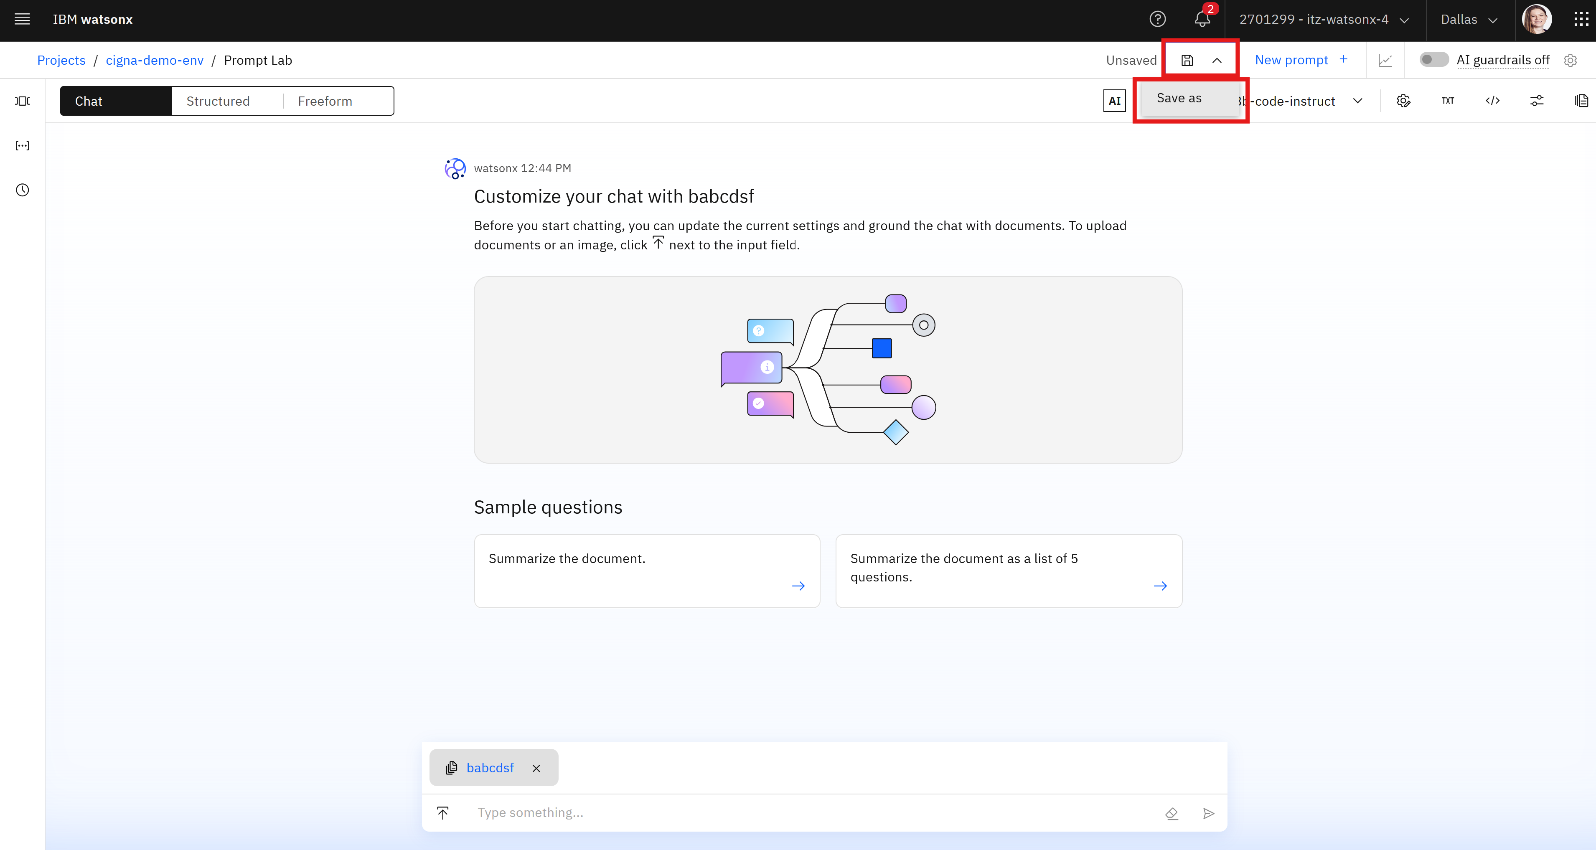

* 1. Choose the asset type you want to save it as:
     1. **Prompt Template:** if you want to save the prompt template (including text of prompt) for future use.
     2. **Prompt Session:** to save the template and questions /responses during your testing.
     3. **Notebook:** to save the prompt text, model used, and example use of prompt formatted into Jupyter notebook (python code)

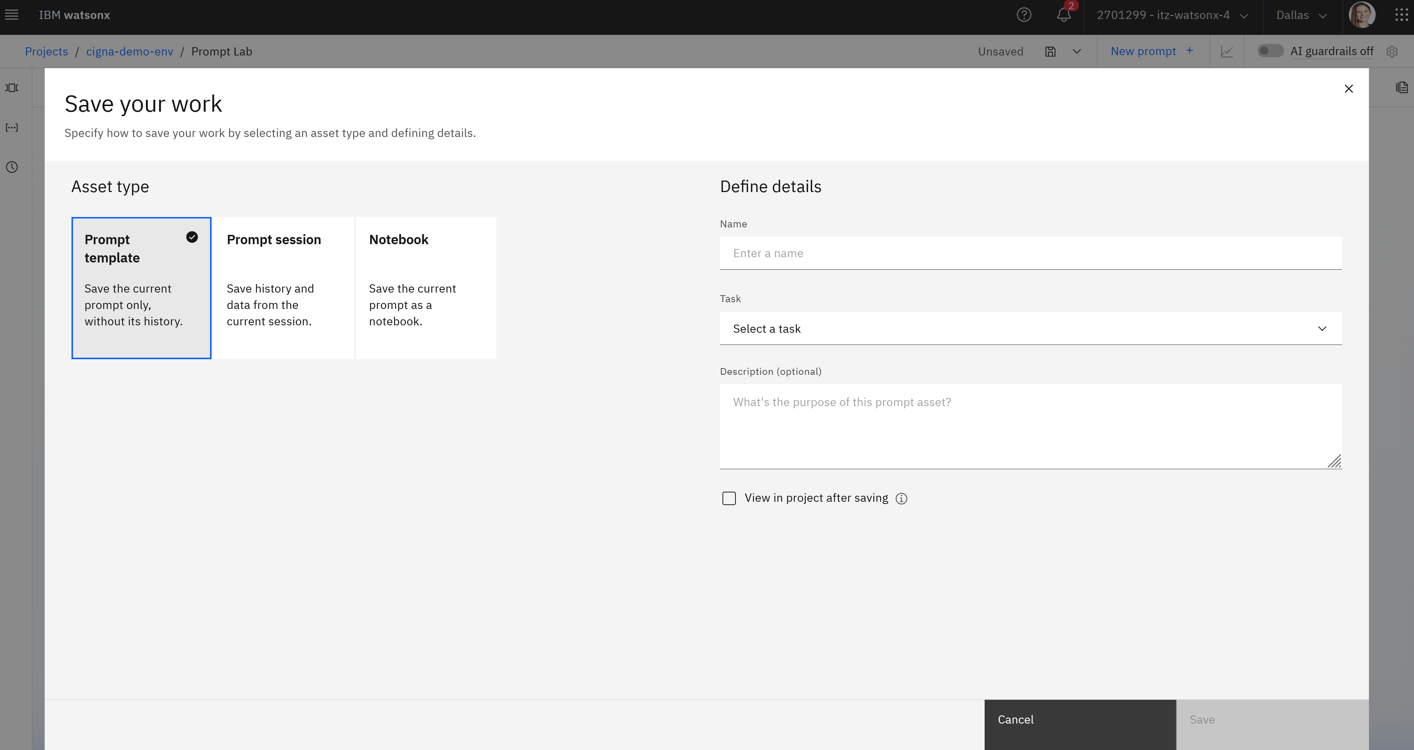

* 1. Give your saved asset a name and select the type of task the prompt is designed to do. Optionally add a description. Finally, click **Save.**
  2. To view where the asset was saved, navigate up to the project level:

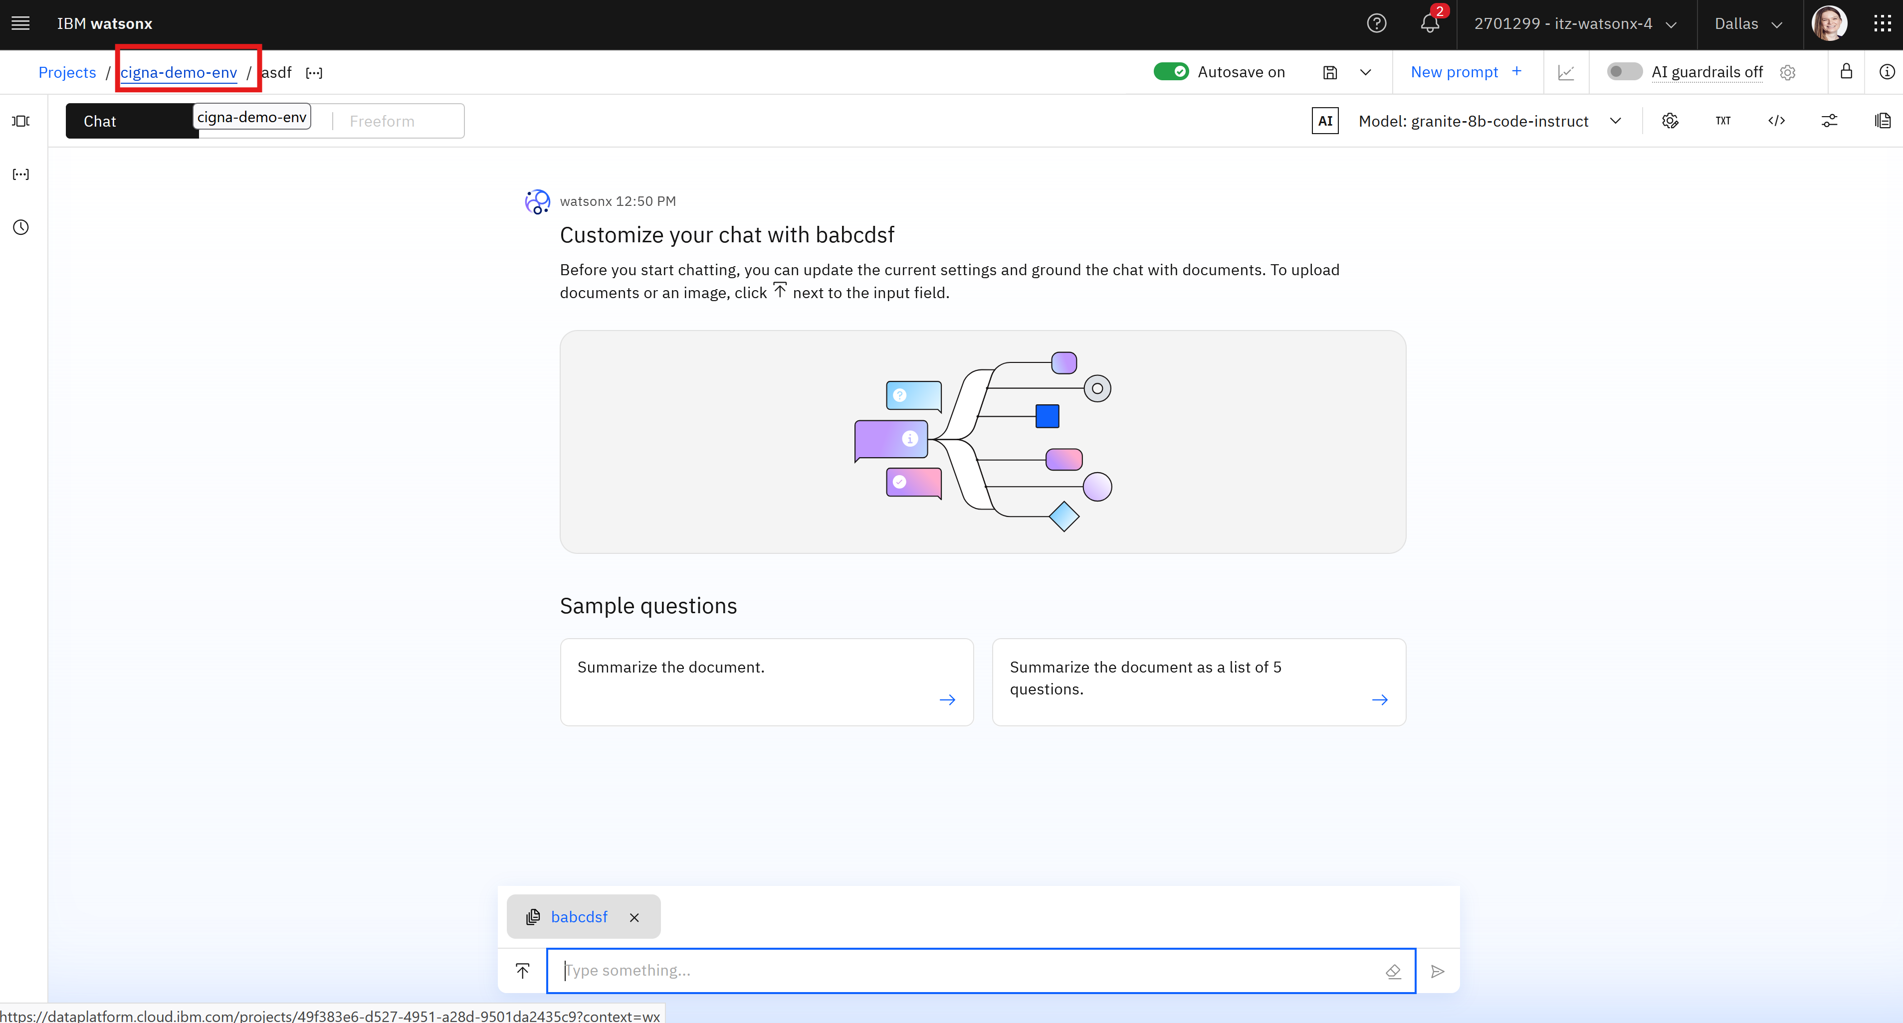

* 1. Click **Assets** tab:

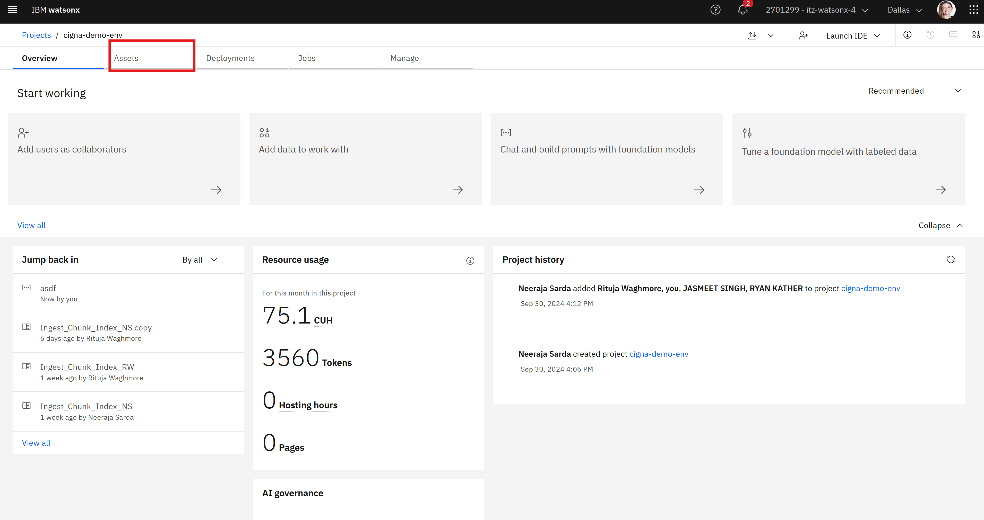

* 1. Find the asset in the list:

